18th Meeting of the United Nations Committee of Experts on Environmental-Economic Accounting

Online

Rules of engagement

Rules of engagement for the 18th Meeting of the UNCEEA

To ensure the virtual meeting runs as smoothly and effectively as possible, we would like to suggest the following ground rules.

Teams as video conferencing tool
We will use Teams as our video conferencing tool. To use the software, all you need to do is click on the link provided in the meeting invitation. You may be asked to accept a client application. If you have difficulty accepting it, you may use the browser version of Teams. If possible, however, refrain from using the browser version and try to use the client application, since the browser version has some limitations.

The best browsers for Teams are Chrome and Edge. All others have some limitations. Therefore, please make sure you have Chrome or Edge and make it the default browser for the period of the meeting. You may also use your smartphone or tablet to join the meeting. In the past, participants have often had success in connecting to Teams with their smartphone or tablet when their computer has not worked.

Please note that the meeting organizers are unable to provide technical support with Teams or any other connection issues. For technical support you will need to contact your own IT support. You can also set-up a Teams account at Log In | Microsoft Teams and test it yourself in advance.

Ensure access to a stable internet connection
Please test your connection prior to the meeting to avoid running into problems during the discussion. While we would appreciate it if everybody uses the video function, please consider joining the meeting solely through the audio function if your internet connection is weak.

Providing statements
We welcome everyone’s active engagement and contributions in the meeting. However, there will be a quite large number of participants in the meeting, and the time is limited. Therefore, please keep your interventions to 2 minutes, maximum. In addition, please space out your interventions so that all have an opportunity to speak.

If there are multiple representatives attending from your country or organization, kindly coordinate your responses as much as possible and limit the number of speakers per country. If possible, try to designate 1-2 persons as speakers.

To make your intervention or ask a question, you may either raise your digital hand or use the chat box (see below for greater explanation). Please note that we encourage spoken interventions. Please consider reserving the chat box for short concise interventions, such as voicing agreement or support, or if you have a poor audio connection.

Raising your hand and using the chat box

Raise your digital hand. At the top of the window, you will see several icons, including one of a hand (see below). Click on that once, and your raised hand will appear to the participants and host. Since many might have raised their hands, the host will move from hand to hand until you get your turn. After you are given the chance to make your contribution, please click on the hand icon again to lower your hand.

Send a chat message. In the same menu bar next, you will find a chat icon (see below). Click that and a chat window will open. You can enter your comments or question there. By default, the chat message will go to everyone.
View/hide participants pane

Stop/start video
Raise/lower your digital hand
Chat
Mute/unmute

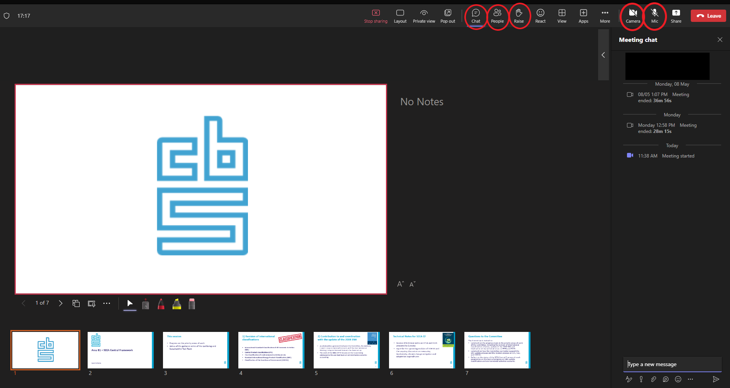

Mute your microphone while not speaking
Since there will be lot of participants in plenary, the meeting host may mute all to improve the quality of the connection. Whenever you are given the chance to speak (after you have raised your digital hand), please unmute yourself and then mute yourself again after speaking (see screenshot). This will ensure there is no background noise.

Use a quiet place for the meeting
Please use a quiet place for the meetings to avoid interruptions and disturbing noises.

Use headphones
Use headphones with an integrated microphone to ensure the best audio quality. Ear plugs used for smart phones can also be used.

Recording
The meeting may be recorded. However, it will not be distributed publicly.

