Instructions:
- Download “TrainingData” Folder from: https://drive.google.com/open?id=1bH-IcOldDBz4MVwLQhslNUTFoMEqgEO7

- Open QGIS (this exercise is made fro QGIX version 2.18, but can be also done in newer versions)

- Examine left panel- the two most important buttons are the first two: Add Vector Layer (Vetorial) and Add Raster Layer (Raster).

- Load in (add) the polygon vector layer “RioGrandeLCLU.shp” within your TrainingData Folder (this contains land cover land use data for the Rio Grande Basin

- Right click on the “RioGrandeLCLU” and explore the table of attributes associated with the polygon layer. (Open Attribute Table / Abrir taela de atributos)

- Check projection: geographic or projected? If geographic, change to appropriate projection for Brazil.

- Now we will populate a table with the name descriptions so we can visualise both the individual land use land cover census maps and changes over time in context. You can do this in a spreadsheet or a text editor; on the IBGE computers try using LibreOffice6.0 (lower left of the desktop), “Planilha Calc” is then the spreadsheet. Create a csv file with three columns: LULC code, Description, Carbon.

LULC code | English | Portuguese
1 | Artificial Surfaces | Area Arificial
2 | Cropland | Area Agricola
3 | Managed Pasture | Pastagem com Manejo
4 | Mosaic of Occupations in Forest Area | Mosaico de Ocupacoes em Area Florestal
5 | Silviculture | Silvicultura
6 | Forest Tree Cover | Vegetacao Florestal
9 | Wetland | Area Umida
10 | Savannah, Shrubland, Grassland | Vegetacao Campestre
11 | Mosaic of Occupations in Savannah, Shrubland, Grassland Area | Mosaico de Ocupacoes em Area Campestre
12 | Inland Water Bodies | Corpo d’agua Continental
13 | Coastal Water Bodies | Corpo d’agua Costeiro
14 | Barren Land | Area Descoberta

- Back to the table, click the edit button (circled at top left) which enables you to click the “New Field” button, circled top near-right). AREA_SQ.

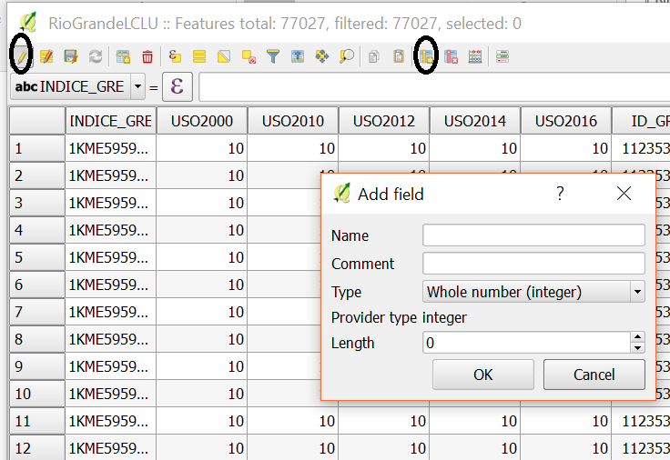
- Name the field: AREA_SQKM. Change type to Float and length to 50. Calculate area.

Coordinate systems and projections

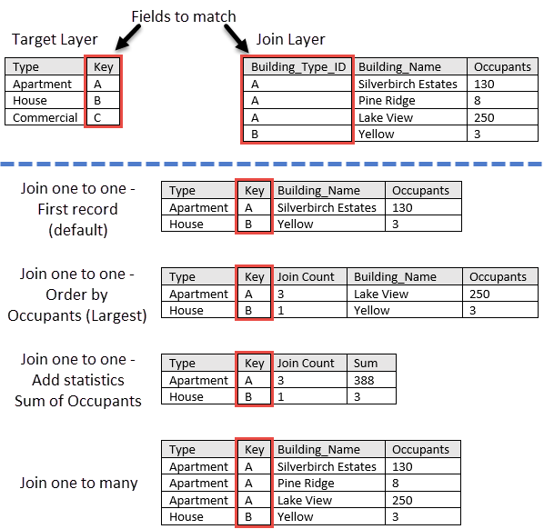

What is a coordinate system?
Coordinate systems enable geographic datasets to use common locations for integration. A coordinate system is a reference system used to represent the locations of geographic features, imagery, and observations. This allows different datasets to be compared with common locations and processed so that all derived data and analysis can be viewed within a single consistent geographic framework.
The two most common types of coordinate systems used within GIS are
- Geographic coordinate systems; global or spherical coordinate systems such as latitude-longitude systems.
- Projected coordinate systems, which use a variety of techniques to project maps of the earth's spherical surface onto a two-dimensional Cartesian coordinate plane. Projected coordinate systems are referred to as map projections. Common projection systems include universal transverse Mercator (UTM) and Albers Equal Area projections, along with numerous other map projection models.
Several hundred geographic coordinate systems and a few thousand projected coordinate systems are available for use. In addition, you can define a custom coordinate system.
Coordinate systems (both geographic and projected) provide a framework for defining real-world locations.

Each coordinate system is defined by the following: Its measurement framework, which is either geographic (in which spherical coordinates are measured from the earth's center) or planimetric (in which the earth's coordinates are projected onto a two-dimensional planar surface)
Units of measurement (typically feet or meters for projected coordinate systems or decimal degrees for latitude-longitude).
A geographic reference system treats the globe as if it were a sphere divided into 360 equal parts called degrees. Each degree is subdivided into 60 minutes. Each minute is composed of 60 seconds. Said differently, an arc-second represents the distance of latitude or longitude traversed on the earth's surface while traveling one second (1/3600th of a degree).
At the equator, an arc-second of longitude approximately equals an arc-second of latitude, which is 1/60th of a nautical mile (or 101.27 feet or 30.87 meters). Arc-seconds of latitude remain nearly constant, while arc-seconds of longitude decrease in a trigonometric cosine-based fashion as one moves toward the earth's poles. At 49 degrees north latitude, along the northern boundary of the Concrete sheet, an arc-second of longitude equals 30.87 meters * 0.6561 (cos 49°) or 20.250 meters. Ideally, a three arc-second grid cell on the north edge of the Concrete sheet measures 60.75 meters along its north side and 92.60 meters along its east and west sides.

The definition of the map projection for projected coordinate systems
Other measurement system properties such as a spheroid of reference, a datum, one or more standard parallels, a central meridian, and possible shifts in the x- and y-directions

What is a spatial reference?
A spatial reference is a series of parameters that define the coordinate system and other spatial properties for each dataset in the geodatabase. It is typical that all datasets for the same area (and in the same geodatabase) use a common spatial reference definition.

A spatial reference includes the following: The coordinate system
The coordinate precision with which coordinates are stored (often referred to as the coordinate resolution)
Processing tolerances (such as the cluster tolerance)
The spatial extent covered by the dataset (often referred to as the spatial domain)

Geographic coordinate systems

A geographic coordinate system (GCS) uses a three-dimensional spherical surface to define locations on the earth. A GCS is often incorrectly called a datum, but a datum is only one part of a GCS. A GCS includes an angular unit of measure, a prime meridian, and a datum (based on a spheroid). The spheroid defines the size and shape of the earth model, while the datum connects the spheroid to the earth's surface.
A point is referenced by its longitude and latitude values. Longitude and latitude are angles measured from the earth's center to a point on the earth's surface. The angles often are measured in degrees (or in grads). The following illustration shows the world as a globe with longitude and latitude values:

