**Executive Summary**

TITLE – Short Policy Brief

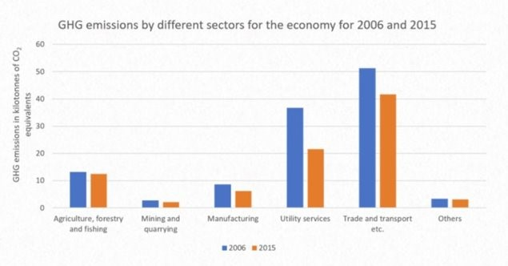

Graphs/Data (example)

Background

Context/Scope

Approach/Methodology

*Place your own logos below*

References

Image/Visual

Policy Recommendations

Results and Findings