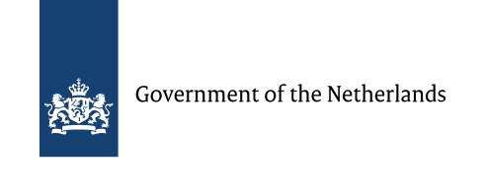
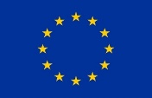

Natural Capital Policy Forum
Working together to improve decision-making: special insights on climate change and biodiversity
November 26-27 2018,
Palais Brongniart, Paris

Note on Logistics

Meeting location
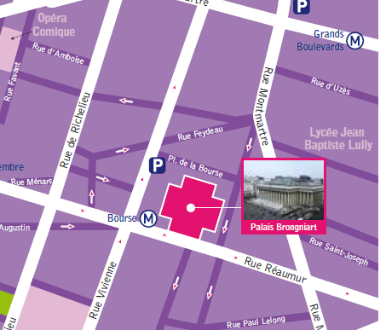
The meeting will be held from November 26-27, 2018 at The Palais Brongniart, 16 Place de la Bourse, 75002 Paris, France in the room Notre Dame des Victoires (Entrance off Rue Notre Dame des Victoires)
Entrance

The meeting will begin at 9.00 am on each of the two days. Participants are requested to leave the hotel around 8.00 am on day one, so that it gives each one adequate time for registration etc. All participants are encouraged to carry some form of official identity i.e. passport, driving licence or national identity card, with them during their stay.

Transportation from the Airport
Participants are requested to find their way to the hotel. Best option would be to hire a taxi to the hotel from the airport. The cost from the airport to a hotel close to the venue would be approximately 44 Euros (50 US Dollars). It is recommended that you change some currency into local currency upon arrival in Paris so that you will be able to pay for the taxi hire, just in case credit cards are not accepted.

Hotels close to the venue

Mercure Paris Opera Louvre (https://www.accorhotels.com/gb/hotel-1614-mercure-paris-opera-louvre-hotel/index.shtml
Hotel Opera Maintenon (https://hotel-opera-maintenon.com/en/
Golden Tulip Washington Opera https://washington-opera.goldentulip.com/en-us/
Hotel Malte https://en.astotel.com/hotel/malte-opera-en/overview

Lunch
Lunch and other refreshments on all days of the event will be provided.

Participants Reception
The Dutch Ambassador Pieter de Gooijer will be kindly hosting all participants to a reception Monday evening at the Netherlands residence, Hôtel d’Avaray, 85 rue de Grenelle, 75007 Paris. A formal invitation with details will be shared closer to the date.
Recommended itinerary by public transport from Palais Brongniart conference centre to the Netherlands residence (25 min):
Take M3 from metro station Bourse in the direction of Pont de Levallois – Bécon. Change at Saint Lazare en take M12 in the direction of Mairie d’Issy. Get off at Solférino and walk 5 min to the residence.
Other stations on walking distance from the residence are:
- Gare Musée d’Orsay (RER C) (8 min walking)
- Sèvres-Babylone (M10) (8 min walking)
- Varenne (M13) (8 min walking)

Weather conditions, time zone, currency, language, electricity
Weather: The average high temperature in Paris will be in the upper to mid-40s Fahrenheit (5-7 °C). https://weather.com/weather/monthly/l/FRXX0076:1:FR

Time zone: GMT + 2 hrs
Currency: Euros
Language: French/ English
Electricity: The electricity in France is 230 volts.

For France there are two associated plug types, types C and E. Plug type C is the plug which has two round pins and plug type E is the plug which has two round pins and a hole for the socket's male earthing pin. France operates on a 230V supply voltage and 50Hz. If your appliance's plug doesn't match the shape of these sockets, you will need a travel plug adapter in order to plug in. Travel plug adapters simply change the shape of your appliance's plug to match whatever type of socket you need to plug into.
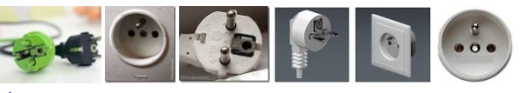

Visiting Paris, France
The official guide from the Paris tourist Office: https://en.parisinfo.com/

Contact persons during the event:
World Bank: Sofia Ahlroth, +1-2027516681
Netherlands: Martin Lok, +31-648132438
UNSD: Alessandra Alfieri, +1-6467336916
Natural Capital Coalition: Marta Santamaria, +44-7468438142

