# SEEA CF and tourism accounts – the Italian experience

Authors: Carolina Ardi, Emanuela Recchini, Angelica Tudini – Istat

Contents

SEEA CF and tourism accounts – the Italian experience 1

Abstract 2

Background and outline of the paper 3

1. The UNWTO international reference framework for measuring sustainable tourism: linking TSA and SEEA 4

2. Tourism related environmental flows from a production perspective: the Italian TSA-SEEA case study 9

2.1 Purpose of the case study and main output 9

2.2 Methodology 12

2.2.1 Estimating environmental flows by tourism industry 12

2.2.2 Estimating the tourism share of environmental flows by tourism industry 14

3. Tourism related environmental flows from a consumption perspective, an open question 15

4. Conclusions and inputs for discussion 16

Main references 18

ANNEX - TSA-SEEA integrated framework - Italy (2015) 19

**Acknowledgements**

Cesare Costantino, UNWTO Consultant, provided methodological and conceptual advice throughout the Italian pilot study. We are also grateful for the precious inputs, clarifications and review made available for this paper.

We would like to thank our colleagues Sandra Maresca and Ilaria Piscitelli for the detailed explanations on the Italian TSA.

All responsibilities for possible misunderstandings and mistakes are of course our own.

## Abstract

Since 2015, developing accounting frameworks for sustainable tourism has been one of the main objectives of the Measuring Sustainable Tourism (MST) project, launched by the World Tourism Organization (UNWTO) in cooperation with the UN Statistics Division (UNSD) and supported by the UN Statistical Commission (UNWTO, 2016). In the UNWTO approach, the proposed statistical framework for measuring sustainable tourism (SF-MST) is very much centred on the integration of two existing accounting frameworks – the Tourism Satellite Accounts (TSA) and the System of Environmental-Economic Accounting (SEEA), both consistent with the accounting framework for measuring the economy – the System of National Accounts (SNA). An initial set of relevant accounts and tables and related indicatorsas well as implementation guidelines are provided in a technical note on linking TSA and SEEA (UNWTO, 2018a) prepared upon encouragement by the UN Committee of Experts on Environmental-Economic Accounting (UNCEEA) and by the UNWTO Committee on Statistics and the TSA*.* Further methodological developments, including for example coverage of the social dimension, are provided in the draft Statistical Framework for Measuring Sustainable Tourism (UNWTO, 2018b).

Within the current SEEA the integration of the economic and the environmental dimensions as concerns specifically the tourism sector is dealt with in the 2012 SEEA applications and extensions. In the context of the SEEA revision, the output of the collaborative UNWTO and UNSD project will allow to develop key aspects of integrating tourism and environmental information beyond those already covered. This development is one of the subjects selected for long term development.

Istat, as a member of the UNWTO Working Group of Experts on Measuring the Sustainability of Tourism, has been involved in the consultations on the draft Statistical Framework and also contributed to the UNWTO project by developing a pilot study on environmentally extended tourism satellite accounts for Italy.

The first part of the paper deals with the measurement of environmental flows related to tourism industries as well as the portion attributable to visitor activity and hence to tourism (the so called tourism share of environmental flows), on the basis of the experience gained in the context of the Italian case study.

The second part of the paper covers the issue of the calculation of environmental flows according to the consumption perspective, not implemented in the Italian case study.

## Background and outline of the paper

The Measuring Sustainable Tourism (MST) initiative of the UN World Tourism Organization (UNWTO) with the partnership of the United Nations Statistics Division (UNSD), launched in 2015, aims, in general, at improving the organization and dissemination of statistical information regarding tourism and sustainable development.

Within this general context, which covers the economic, environmental and social dimensions of sustainable tourism this paper deals with one specific stream of work, i.e. the design and implementation of an accounting framework describing the interrelationships between economic and environmental aspects of tourism[1].

Recognizing that accounting frameworks have a high potential for measuring the sustainability of tourism, the main idea behind the MST project is to integrate two existing accounting frameworks: the Tourism Satellite Accounts (TSA[2]) and the System of Environmental-Economic Accounting (SEEA[3]), both consistent with the accounting framework for measuring the economy – the System of National Accounts (SNA).

The TSA, which provides the definition and classification of tourism products, tourism characteristic activities and tourism industries, aims at measuring tourism activity and its economic contribution, from two main standpoints, specifically:

* Demand perspective, mainly focusing on tourism *expenditure* and *consumption*,
* Supply perspective, encompassing tourism direct *gross value added*, tourism *employment* and *gross fixed capital formation* of tourism industries.

Within the current SEEA the integration of the economic and the environmental dimensions as concerns specifically the tourism sector is dealt with in the 2012 SEEA applications and extensions. By integrating TSA and SEEA accounts in a comprehensive framework (TSA-SEEA), environmental flows and assets relevant to tourism activities (whose economic contribution is measured by TSA), can be identified and measured.

The MST identifies three main types of TSA-SEEA integration in support of the measurement of sustainable tourism [4]:

* connections between SEEA based accounts for individual environmental flows (e.g. water, energy, waste) and tourism activity
* accounting for produced and environmental assets relevant to tourism
* spatial accounting for tourism activity applying the logic of SEEA based land and ecosystem accounting.

This paper deals with the first type, i.e. accounting for environmental flows for tourism activity. The main reference for this kind of exercise is the TSA-SEEA Technical Note (UNWTO, 2018a), prepared upon encouragement by the UN Committee of Experts on Environmental-Economic Accounting (UNCEEA) and by the UNWTO Committee on Statistics and the TSA.

Paragraph 1 introduces the initial set of relevant accounts and tables and related indicatorspresented in the Technical Note and some guidelines aiming at supporting the implementation of the integrated accounts.

Beyond the development of a reference statistical framework, one additional objective of the MST project is to stimulate pilot implementation at country and sub-national levels. Italy is one of several countries[5] that produced a pilot study. Paragraph 2 presents the scope of the Italian TSA-SEEA pilot study and its methodology. The main aim here is to highlight the extent to which the Technical Note guidelines were applied in the pilot study as well as other methodological findings that can be of interest for other countries engaging in studying the interaction between economic and environmental aspects of tourism activities by means of a TSA-SEEA framework.

The Italian pilot study adopts a production perspective in producing initial estimates of environmental flows related to tourism, and this is a common feature of implementation studies to date. Paragraph 3 focuses on the TSA-SEEA integration from a demand perspective in order to provide a conceptual basis for estimating tourism related environmental flows also from this standpoint.

In the context of the SEEA revision, the output of the collaborative UNWTO and UNSD project will allow to develop key aspects of integrating tourism and environmental information beyond those already covered in the current SEEA. This development is one of the subjects selected for long term development.

## The UNWTO international reference framework for measuring sustainable tourism: linking TSA and SEEA

Developing accounting frameworks for sustainable tourism by integrating the Tourism Satellite Accounts (TSA) and the System of Environmental-Economic Accounting (SEEA) has been one of the main objectives of the MST project, since its start in 2015.

This paragraph focuses on the initial set of relevant accounts and tables and related indicators developed in the TSA-SEEA technical note (UNWTO, 2018a), prepared upon encouragement by the UN Committee of Experts on Environmental-Economic Accounting (UNCEEA) and by the UNWTO Committee on Tourism Statistics and TSA*.*

The initial set of integrated core accounts presented in the Technical Note covers four physical supply and use tables, specifically: Tourism industries water flow account (in cubic metres), Tourism industries energy flow account (in joules), Tourism industries GHG emissions account (in tonnes), Tourism industries solid waste account (in tonnes)[6]. The common approach of the four accounts is from a production[7] perspective.

The Tourism industries energy flow account and Tourism industries GHG emissions account are shown respectively in Table 1 and 2 below. As can be seen in the Tables, the tourism supply and use tables for environmental flows are fully consistent with the corresponding SEEA tables, the main specific feature being that environmental flows are recorded for tourism industries following the TSA classification rather than for all industries in the economy following the ISIC classification.

Another distinguishing feature of the tourism flow accounts with respect to the SEEA flow accounts, is that, consistently with TSA Table 6 ‘Total domestic supply and internal tourism consumption’, for tourism industries and for other industries serving visitors, two kinds of environmental flows are recorded for each industry:

* for the industry as a whole (‘Total’ in in Tables 1 and 2 below)
* for the part attributable to visitor activity and hence to tourism, so called tourism share (‘Tsm’ in Tables 1 and 2 below). The TSA recommended methodological framework defines the Tourism share as: the ‘*share of the corresponding fraction of internal tourism consumption in each component of supply. For each industry, the tourism share of output (in value), is the sum of the tourism share corresponding to each product component of its output*’. (UNWTO et al, 2010, Glossary of terms).

Table 1– Tourism industries energy flow account (joules*)

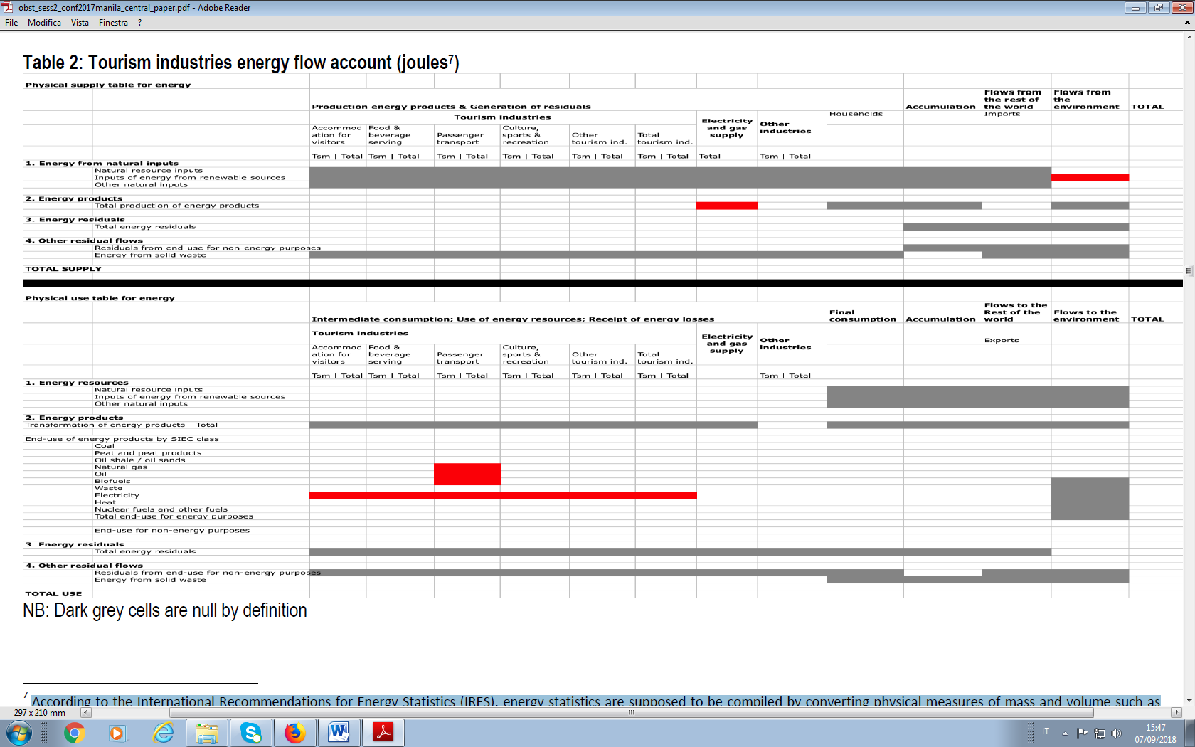

[Source, UNWTO (2018a)]

* According to the International Recommendations for Energy Statistics (IRES), energy statistics are supposed to be compiled by converting physical measures of mass and volume such as tonnes, litres and cubic metres into a common unit representing energy content in net calorific terms. Joule is the common unit generally used for expressing energy flows. ’Tsm’ is the component of any energy flow attributable to visitor activity and hence to tourism, so called tourism share, ’Total’ is the total energy flow for any industry regardless of the portion attributable to tourism consumption. Key cells for the compilation of this account are highlighted in red.

**Table 2: Tourism industries GHG emissions account (tonnes)**

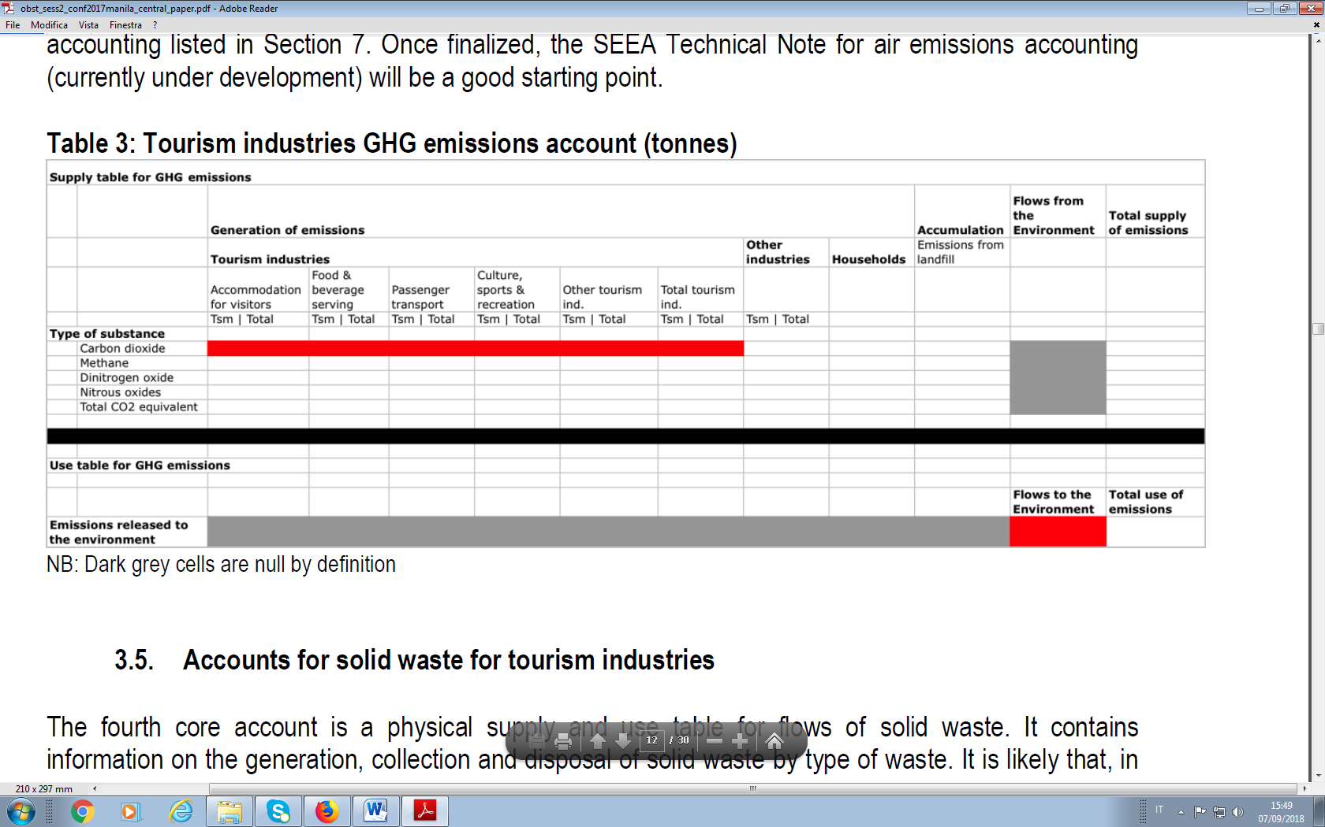

[Source, UNWTO (2018a)]; key cells for the compilation of this account are highlighted in red. For each industry, ’Tsm’ is the component of any emitted substance attributable to visitor activity and hence to tourism, so called tourism share, ’Total’ is the total substance emitted by any industry regardless of the portion attributable to tourism consumption.

In addition to developing the accounts framework, the Technical Note also provides methodological advice to calculate the tourism share of environmental flows, (Tsm in the Tables), i.e. to distinguish, out of the total amount of an environmental flow (water, energy, GHG emissions, solid waste, etc.) related to an industry serving visitors – the component attributable to visitor activity and hence to tourism, i.e. the tourism share of environmental flows. On the basis of the detailed analysis of the matter provided in Costantino (2017), the Technical Note, suggests, in the absence of directly collected data, to use preferably ratios derived from a TSA: output ratios and intermediate consumption ratios. For example, the tourism share of GHG emissions of the air transport industry may be estimated by multiplying the total GHG emissions of that industry by the output ratio attributable to visitor consumption in the TSA. Output ratios are obtained by dividing an industry’s output sold to visitors by its total output; and intermediate consumption ratios can be similarly derived[8]. The suggested criterion for choosing between the two indicators is as follows: output ratios should be used where the magnitude of the environmental flow of interest is directly related to the level of production (e.g. GHG emissions and solid waste) while intermediate consumption ratios are best applied for those environmental flows that are inputs to production (e.g. energy).

Economic information on tourism industries (compiled within the TSA framework) can also be presented side by side with information on environmental flows (compiled following the core integrated TSA-SEEA accounts) within the framework of a *combined presentation*(Table 3).

**Table 3 – Combined presentation for tourism industries**

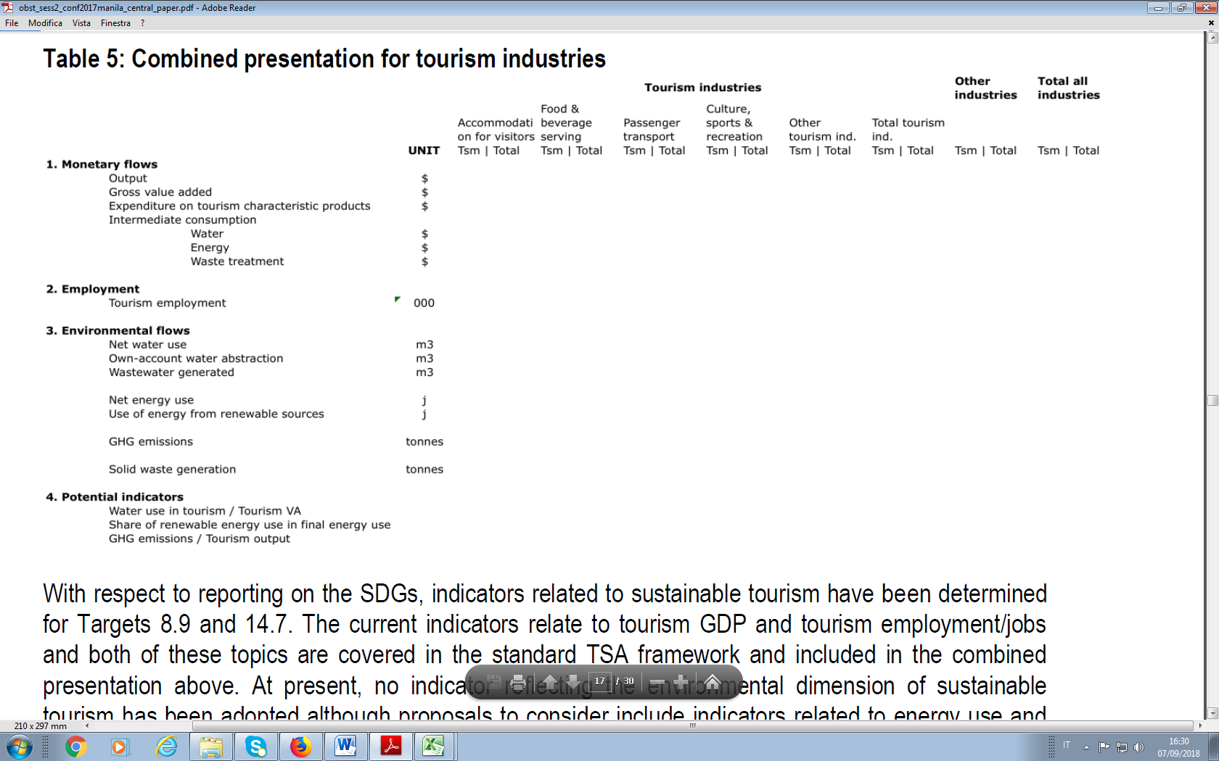

[Source, UNWTO (2018a)]. For each industry, ’Tsm’ is the component attributable to visitor activity and hence to tourism, so called tourism share, ’Total’ is the total regardless of the portion attributable to tourism consumption.

## Tourism related environmental flows from a production perspective: the Italian TSA-SEEA case study

### 2.1 Purpose of the case study and main output

According to the TSA, in Italy value added generated by tourism-related economic activities in 2015 amounts to almost 90 billion euros, around 6% of total value added, two percentage points higher than the average value for OECD member countries. Internal tourism consumption is almost 150 billion euros in the same year. Around 44% of visitors’ consumption stems from domestic tourism[9] and around 33% from inbound tourism[10], the remaining 23% being represented by other components of tourism consumption[11]. As regards the employment in the tourism industries, the overall number of full-time equivalent employees recorded in 2015 comes close to 3.2 million. Italy's balance of inbound tourism expenditure and outbound tourism expenditure is structurally in surplus[12].

At the Meeting of the UNWTO Working Group of experts on Measuring Sustainable Tourism held in October 2016, Italy, as a member of the Working Group, proposed to develop a case study with the following main objectives:

1. to identify environmental accounts suitable for an environmentally extended tourism satellite accounts for Italy;
2. to estimate environmental flows directly generated by tourism industries as well as the tourism shares of the same environmental flows for Italy with reference to the environmental accounts identified above;
3. to analyze the feasibility of producing regular integrated TSA-SEEA estimates for Italy;
4. to assess possible extensions to environmental variables not covered in the pilot study[13].

As concerns objective a) one of the key requisites for developing the integrated core accounts of the Technical Note (where environmental flows following the SEEA are broken down by TSA industries) is the availability of environmental accounts by NACE. As a Member of Eu Italy regularly produces data for five environmental accounts covered by Eu Regulation on European environmental economic accounts (Reg. 691/2011 and Reg. 538/2014 amending Reg. 691/2011): air emission accounts, environmentally related taxes by economic activity, economy-wide material flow accounts, environmental protection expenditure accounts, physical energy flow accounts; in addition environmental goods and services sector accounts will be finalized by the end of 2018.

The availability of data broken down by NACE makes air emission accounts, intermediate consumption of energy products in physical terms and environmentally related taxes the best candidates for inclusion in an environmentally extended tourism satellite accounts for Italy in the short term. For the first pilot implementation of a TSA-SEEA for Italy, air emission accounts and the intermediate consumption of energy products in physical terms, were selected.

As concerns objective b), Annex I presents the main output of the pilot study, i.e. a TSA-SEEA Table 6, namely a standard TSA Table 6 ‘Domestic supply and internal tourism consumption by products’ combined with four additional rows for environmental flows:

• air emissions– 3 environmental themes: greenhouse gases (GHG), acidification and ground level ozone[14]

• energy – total intermediate consumption of energy products

A simplified scheme of the TSA-SEEA Table 6 is presented in Table 4.

Possible uses of the TSA-SEEA data are:

• to compare the emission and energy intensity of tourism industries (individually or as a whole) with the corresponding intensities for other industries or for the total production activities in the economy

• to derive environmental profiles (for individual industries or grouping of) showing the percentage contribution to the generation of economic output side by side to the percentage contribution to the generation of environmental pressures, in this case air emissions and energy use

• to calculate the breakdown by tourism industries of economic and related environmental variables.

Table 4 – Simplified scheme of the TSA-SEEA Table 6



*O = Output (corresponds to “Total” reported in the previous Tables 1-3); TS = Tourism Share (it corresponds to “Tsm” reported in the previous Tables 1-3).

For both air emissions and energy input two environmental flow (EF) estimates were produced:

1. **environmental flows by tourism industry** (regardless of the proportion directly attributable to tourism): **EF_EMI_TOURind(i)** and **EF_EUQ_TOURind(i),** where **EF** stands for environmental flow**, EMI** for air emissions, **EUQ** for energy use data in quantity terms, **TOURind(i)** are the 11 tourism industries listed in Table 5, column 1.
2. **tourism share (TS) of environmental flows by tourism industry,** i.e. the portion – out of the total amount of environmental flows related to a tourism industry –attributable to consumption by visitors and hence to tourism:  **EF_EMI_TS(i)** and **EF_EUQ_TS(i)**

The methodology is explained in the following sub-paragraph.

Regarding pilot study objectives c) and d), i.e. assessment of the feasibility of producing regular integrated TSA-SEEA estimates for Italy as well as possible extensions to environmental variables not covered in the pilot study, main conclusions are as follows:

* the annual release of air emission account and intermediate consumption of energy products in physical terms by NACE, makes TSA-SEEA estimates for Italy regularly feasible for these accounts, for years in which a TSA is also available;
* EF estimates could be extended to environmental taxes by applying the same method explained below for air emissions and energy use.

### 2.2 Methodology

#### 2.2.1 Estimating environmental flows by tourism industry[15]

The purpose of the exercise is to estimate environmental flows by tourism industry (regardless of the proportion directly attributable to tourism): **EF_EMI_TOURind(i)** and **EF_EUQ_TOURind(i)**, where (i) are the 11 tourism industries listed in Table 5, column 1.

The starting point are environmental flows by national accounts industries, available from annual air emission accounts and physical energy flow accounts: **EF_EMI_NA(j)** and **EF_EUQ_NA(j),** where j are the national accounts economic activities listed in column 2 of Table 5.

Table 5- Tourism industries (a), corresponding NA economic activities (b); differences in scope between (a) and (b).

|  |  |  |
| --- | --- | --- |
| **Tourism industry (a)** | **NA economic activity (b)** | **Difference in scope - portion of NA economic activity (b) not included in tourism industry (a)** |
| 1- Accommodation for visitors | Accommodation | Accommodation for students, and workers such as student residences, school dormitories, workers hostels |
| Buying and selling of real estate and real estate activities for third parties | No conceptual difference in scope but the portion of real estate activities not related to tourism is not included |
| Rental and management of properties owned or leased | See above |
| 2- Food and beverage serving activities | Food and beverage serving activities | Event catering and other food service activities |
| 3- Railway passenger transport | Railway transport | Freight rail transport |
| 4- Road passenger transport | Other land passenger transport | Urban and suburban passenger land transport |
| 5- Water passenger transport | Maritime and inland water transport | Sea, inland and coastal freight water transport |
| 6- Air passenger transport | Air transport | Freight air transport and space transport |
| 7- Transport equipment rental | Renting and operating leasing activities | Renting and leasing of recreational and sports goods (part of tourism industry 10 – sport and recreational industry) |
| 8- Travel agencies and other reservation services industry | Services activities of Travel agencies, Tourism Operators and related reservation services and activities | No difference in scope but the portion of output related to package tours is not included |
| 9- Cultural activities | Creative, arts and entertainment activities | None |
| Libraries, archives, museums and other cultural activities | Library and archives activities |
| 10- Sports and recreational industry | Lotteries, betting and casinos related activities | None |
| Sports, amusement and recreation activities | Activities of sports clubs. Fitness facilities |
| 11 - Retail trade of country specific goods | Retail trade, except of motor vehicles and motorcycles | Retail trade of country non tourism specific goods |

As a first step, the scope of the national accounts economic activities (column 2 of Table 5) for which EF are already available, is compared to the scope of the corresponding tourism industry (column 1); column 3 of Table 5 specifies the actual difference in scope for each case.

If a national accounts economic activity (col 2) and the corresponding tourism industry (col 1) have the same scope (no difference reported in column 3), the environmental flow of the tourism industry is equal to the (known) environmental flow of the specific corresponding national accounts economic activity:

* 1. **EF_EMI_TOURind(i) = EF_EMI_NA(j)** and
  2. **EF_EUQ_TOURind(i) = EF_EUQ_NA(j)** (where ***i***are the 11 tourism industries listed in Table 5 and ***j*** are the corresponding national accounts economic activities)[16].

If the scope of tourism industry is **smaller** than the corresponding NA economic activity, the amount of environmental flow for the tourism industry is calculated consistently as far as possible with the method applied to estimate output in the Italian TSA.

In the Italian TSA, output by tourism industry is estimated by breaking down NA output at the NACE class level (4-digit) and summing up as tourism output only the classes actually falling within the scope of tourism (that is to say, subtracting from NA activity output the portion of output related to classes falling outside the scope of tourism). In estimating environmental flows, the **first best option** is to exactly match the TSA output method, i.e. to quantify the specific amount of emissions/energy inputs related to activities falling within the tourism scope (that is to say, subtracting from NA activity-environmental flow the portion related to classes falling outside the scope of tourism) [17]. In practice a **second best option** isapplied in most cases:

**(2.1) EF_EMI_TOURind(i)= EF_EMI_NA(j) * output_TOURind(i)/ output_NA(j)**

**(2.2) EF_EUQ_TOURind(i)= EF_EUQ_NA(j) * output_TOURind(i)/ output_NA(j)**

i.e. the environmental flows for tourism industries are estimated as a proportion of the related NA economic activity equal to the TSA output ratio (tourism industry/NA).

#### 2.2.2 Estimating the tourism share of environmental flows by tourism industry

**Tourism share of environmental flows by industry**, can be calculated on the basis of TSA tourism output ratios (output_TS(i)/output_TOURind(i)):

**(3.1) EF_EMI_TS(i)**= **EF_EMI_TOURind(i)** * **(output_TS(i)/output_TOURind(i))**

**(3.2) EF_EUQ_TS(i)**= **EF_EUQ_TOURind(i)** * **(output_TS(i)/output_TOURind(i))**

In TSA Table 6, output and output tourism share are available not only by tourism industry, but also, for each tourism industry, by individual product. Ideally, then, estimates of TSA consistent environmental flows can be based on tourism output ratios by product,

i.e. **output_TS(ip)/ output_TOURind(ip)**

Where ***p*** are the TSA products supplied by tourism industry ***i***.

However, in order for the tourism output ratios by product to be actually used in the estimates, also a consistent environmental flows breakdown by TSA product (or grouping of products) is needed.

In practice, a breakdown matching TSA products is available in Italian official statistics for air emissions and energy use of the following tourism industries[18]:

3- Railway passenger transport

4- Road passenger transport

5- Water passenger transport

6- Air passenger transport

In the case of the four tourism industries that supply transport services, the emissions/energy use related to the specific transport activity supplied can be identified as specific subsets of the total emissions/energy use of the industry. Hence, in this four cases environmental flows (EF) of the tourism industry are calculated as the sum of two components:

1. EF related to the provision of the specific transport service (railway, road, water or air transport, respectively);

2. EF related to the provision of all other products

Correspondingly, two product specific environmental flows can be calculated:

**(4) EF_TS(ip)**= **EF_TOURind(ip)** * **(output_TS(ip)/output_TOURind(ip))**

Where

i= 3,4,5,6 i.e. the four industries listed above and

p=1 (related to the specific transport mode corresponding to the principal activity of industry i), 2 (all other EF).

For tourism industries other than the four transport industries listed above, transport emissions in air emission accounts relate to transport as an ancillary activity and therefore cannot be related to the (secondary) output of TSA Table 6. Hence total tourism output ratios by industry (i) were used to estimate tourism share of environmental flows (see 3.1 and 3.2 above), in all cases but the four listed above.

## Tourism related environmental flows from a consumption perspective[19], an open question

As explained in paragraph 2, estimates of environmental flows in the Italian case study, and in other implementation studies to date, adopt a production perspective and relate to tourism industries only.

However, the tourism environmental flow accounts framework presented in the Technical Note (see Tables 1 and 2), although adopting a production perspective by representing the environmental flows related to industries, also explicitly cover households’ related environmental flows. This is a common feature of SEEA environmental flow accounts, where a supply based approach (environmental flows stemming from the supply of products) is complemented with the inclusion of one component related to consumption (environmental flows stemming from the use of products), this way representing total environmental flows.

Measuring also households’ related tourism environmental flows (see again Tables 1 and 2) would therefore be an important step as it would allow to calculate total tourism-related environmental flows. However, the definition of a methodology for the calculation raises a number of questions that are only briefly mentioned here, with reference to the case of GHGs: how to single out the portion of emissions to be attributed to visitors out of total household emissions covered by environmental accounts? How to estimate environmental flows for all categories of visitors as covered in the TSA? For example, since household emissions relate to resident households only, emission accounts data would be a suitable source to calculate for domestic and outbound tourism related emissions but not for inbound, i.e. for emissions related to non-resident visitors’ activities. What kind of statistical relationship exists between visitors' expenditure (e.g. for the fuel that generates air pollutants when it is used in driving and heating) and visitors’ emissions?

This paper does not aim at providing an exhaustive list of questions nor at answering all of them. Instead, the purpose here is to highlight the need to devote further thought to unresolved implementation issues concerning consumption related tourism environmental flows in order to improve the overall statistical representation of integrated environmental and economic tourism accounts.

In addition, going beyond the production approach in tourism related environmental flows estimates is crucial given that the demand perspective is by definition the starting point for addressing matters related to tourism. Any tourism phenomenon, can in fact be traced to a demand reflecting the needs of individuals moving away from their usual environment for tourism purposes. The supply of goods and services purchased by visitors takes place in response to such a demand .

In the TSA, depending on visitors' residence and the economic territory within which the activity of visitors takes place, the demand perspective covers three forms of tourism: activities of resident visitors within the country of reference (Domestic tourism), activities of non-resident visitors within the country of reference (Inbound tourism) and activities of resident visitors outside the country of reference (Outbound tourism). Expenditure and consumption aggregates for the three forms of tourism, provide statistical information from a demand perspective .

A relevant issue currently investigated in the framework of the MST project is how to extend the scope of the demand perspective approach of the TSA to encompass visitors’ activities beyond the use of goods and services supplied in the economic system, i.e. those based on benefits from ecosystem services; this would imply taking into account related environmental impacts on environmental assets. Furthermore, while the demand perspective presented in the international statistical standards for tourism focuses on direct flows - i.e. visitors’ consumption stemming directly from needs related to trips taken by households and individuals is measured - there is an interest also in considering environmental flows along the whole supply chain concerning products purchased by visitors[20].

## Conclusions and inputs for discussion

The implementation of a pilot TSA-SEEA case study for Italy allows to draw some general conclusions that can be helpful for countries engaging in similar exercises:

1. Linking TSA and SEEA is a relatively new statistical effort; the statistical framework proposed within the UNWTO MST initiative and the Technical Note provides help in this respect.

Developing a suitable methodology proved to be the main challenge for the Italian pilot case study. Particularly helpful was the Technical Note methodological advice to calculate the tourism share of environmental flows (in the absence of directly collected data) on the basis of ratios derived from a TSA.

1. Cooperation between TSA and SEEA experts is essential: understanding how TSA estimates were obtained in the first place, facilitates consistency between TSA estimates and environmental flows estimates in TSA-SEEA implementation; access to working level TSA data is also helpful since it allows to perform calculations at a detailed breakdown level.

As discussed in § 2, in estimating environmental flows by industry, the identified first best option was to exactly match the TSA output calculation method, i.e. to quantify the specific amount of emissions/energy inputs related to activities falling within the tourism scope (that is to say, subtracting from NA activity-environmental flow the portion related to classes falling outside the scope of tourism). Although this option was not actually feasible in practice in most cases, it was nonetheless identified as the best one.

1. Access to working level for SEEA accounts can allow to improve the methodology outlined in the general guidelines and is therefore an important requirement for any implementation exercise.

As explained in § 2, in order to estimate the tourism share of emissions and energy use, the Italian TSA-SEEA case study applies in many instances the Technical Note suggestion to use TSA derived output ratios, calculated by dividing an industry’s output sold to visitors by its total output. However, the Italian case study, also calculates product specific coefficients to derive tourism shares for environmental flows in the case of the four tourism industries that supply transport services (3- Railway passenger transport, 4- Road passenger transport, 5- Water passenger transport, 6- Air passenger transport). This is made possible by the availability of air emissions data broken down not only by NACE but also by process (for example transport and heating) as well as the availability of energy use data by purpose (transport, heating, etc.): air emissions and energy use related to the specific transport service supplied as principal activity can be separately identified in the data sources.

1. Further development of methodological and implementation issues concerning consumption-related tourism environmental flows are needed in order to improve the overall statistical representation of integrated environmental and economic tourism accounts.
2. Ecosystem accounting may play an important role for the purposes of enlarging the demand perspective in measuring the sustainability of tourism to cover impacts directly exerted by visitors on environmental assets.

## Main references

Costantino C., Tudini A. (2005), "How to develop an accounting framework for ecologically sustainable tourism", in Lanza A. – Markandya A. – Pigliaru F. (editors*), The Economics of Tourism and Sustainable Development*, The Fondazione ENI Enrico Mattei series on Economics and the Environment, Edward Elgar, UK, USA

Costantino C. (2017), “Options for allocating environmental flows to tourism through integration of data from tourism and environmental-economic accounts”, Paper prepared for the *17th meeting of the UNWTO Committee on Statistics and Tourism Satellite Accounts*, January 2017, Madrid. <http://statistics.unwto.org/committeestsa_17thmeeting>

Costantino C. (2018, forthcoming), “The demand perspective in measuring the sustainability of tourism with specific focus on environmental aspects”, Paper prepared for the *Second meeting of the UNWTO Working Group of Experts on Measuring the Sustainability of Tourism*, October 2018, Madrid.

Istat (2017), Conto satellite del turismo per l’Italia, <https://www.istat.it/it/archivio/207454>; English version: [http://www.istat.it/en/archive/20 8130](http://www.istat.it/en/archive/20%208130)

Istat (2017) Air emission accounts

<http://dati.istat.it/Index.aspx?lang=en&SubSessionId=7d9da96e-e22f-45ed-a07a-50ac25b25d47> (National Accounts, Environmental Accounts, NAMEA air emissions – NACE REV.2, Production activities -December 2017 release) and related working level data.

Istat (2017) Energy use <http://dati.istat.it/Index.aspx?lang=en&SubSessionId=726e7fe2-422e-4ea7-9386-28bd227346c9> (National Accounts, Environmental Accounts, Energy use accounts, Economic activities – type of use - November 2017 release) and related working level data.

Tudini A. (2016), *Environmentally extended tourism satellite accounts for Italy – Extended outline*; paper prepared for the Meeting of the Working Group of experts on Measuring Sustainable Tourism 20-21 October 2016, UNWTO Headquarters, Madrid, Spain; <http://cf.cdn.unwto.org/sites/all/files/docpdf/mstpilotstudyitaly.pdf>

Tudini A., Ardi C., Recchini E. (2018), *Italy’s MST Pilot Study*, presentation prepared for the 18th Committee on Statistics and the Tourism Satellite Account, UNWTO, Madrid 27-28 February 2018; <http://cf.cdn.unwto.org/sites/all/files/pdf/18thmeeting_item_4.3.1.pdf>

UNWTO et al (2010), *Tourism Satellite Account: Recommended Methodological Framework 2008* <https://unstats.un.org/unsd/publication/Seriesf/SeriesF_80rev1e.pdf>

UNWTO, (2016), *Measuring Sustainable Tourism Project concept note*, <http://cf.cdn.unwto.org/sites/all/files/docpdf/mstconceptnote17032016.pdf>

UNWTO, (2017), *Statistical Framework for Measuring Sustainable Tourism,* Preliminary Draft prepared for the Sixth International Conference on Tourism Statistics Measuring Sustainable Tourism, Manila, Philippines, 21 – 24 June 2017.

UNWTO, (2018a), *Linking the TSA and the SEEA: A Technical Note;* [*http://cf.cdn.unwto.org/sites/all/files/docpdf/tsaseeatechnote.pdf*](http://cf.cdn.unwto.org/sites/all/files/docpdf/tsaseeatechnote.pdf)

UNWTO, (2018b), *Statistical Framework for Measuring Sustainable Tourism;* Consultation Draft <http://cf.cdn.unwto.org/sites/all/files/pdf/sf-mst_feb.pdf>

## ANNEX - TSA-SEEA integrated framework - Italy (2015)

1. For an updated draft of the comprehensive Statistical Framework for Measuring Sustainable Tourism (SF-MST), encompassing all three dimensions of sustainable tourism, see UNWTO (2018b). A subsequent version has been planned for a global consultation in 2018, while a final version is supposed to be submitted to the United Nations Statistical Commission in March in 2020.
2. See the UN manual *Tourism Satellite Account: Recommended Methodological Framework 2008* (TSA: RMF 2008).
3. Reference is made here to the System of Environmental-Economic Accounting 2012 - Central Framework (SEEA-CF) and the System of Environmental-Economic Accounting 2012 - Experimental Ecosystem Accounting (SEEA-EEA).
4. See UNWTO (2018a), § 2.4.
5. A list of pilot studies focusing on selected aspects of the overall MST framework that are of relevance in the specific country context is available at <http://statistics.unwto.org/studies_experience>.
6. See UNWTO (2018a), par. 3.1-3.5.
7. Production perspective and supply perspective are generally used as synonyms; the same applies to demand perspective and consumption perspective.
8. The TSA: RMF 2008 defines the tourism ratio as follows: *for each variable of supply in the Tourism Satellite Account, the tourism ratio is the ratio between the total value of tourism share and total value of the corresponding variable in the Tourism Satellite Account expressed in percentage form* (UNWTO et al, 2010, Glossary of terms).
9. The activities of a resident visitor within the country of reference either as part of a domestic tourism trip (one with a main destination within the country of residence of the visitor) or part of an outbound tourism trip (one with a main destination outside the country of residence of the visitor).
10. The activities of a non-resident visitor within the country of reference on an inbound tourism trip (one with a main destination within the country of reference).
11. The Glossary of terms of the TSA: RMF 2008 explains that ‘Tourism consumption has the same formal definition as tourism expenditure. Nevertheless, the concept of tourism consumption used in the Tourism Satellite Account goes beyond that of tourism expenditure. Actually, besides the amount paid for the acquisition of consumption goods and services, as well as valuables for own use or to give away, for and during tourism trips, which corresponds to monetary transactions (the focus of tourism expenditure), it also includes services associated with vacation accommodation on own account, tourism social transfers in kind and other imputed consumption. These transactions need to be estimated using sources different from information collected directly from the visitors, such as reports on home exchanges, estimations of rents associated with vacation homes, calculations of financial intermediation services indirectly measured (FISIM), etc.’ (UNWTO et al, 2010 – Glossary of terms)
12. The latest release of the Italian TSA covering all TSA tables is available at <https://www.istat.it/it/archivio/207454> (Italian version); a partial English version is also available: <http://www.istat.it/en/archive/208130>
13. See Tudini (2016).
14. GHG includes: carbon dioxide (CO2), hydrofluorocarbons (HFCs), perfluorocarbons (PFCs), sulphur hexafluorides (SF6), methane (CH4), nitrous oxide (N2O), Nitrogen Trifluoride (NF3), all expressed in "tonnes of CO2 equivalents" by applying weights reflecting for each pollutant its 'global warming potential' (GWP) in relation to the GWP of CO2: 1 for CO2, 25 for CH4, 298 for N2O, 17200 for NF3, 22800 for SF6 and various weights for HFCs, PFCs and SF6.

    ACIDIFICATION takes into account: sulphur oxides (SOx), nitrogen oxides (NOx) and ammonia (NH3), all expressed in "tonnes of potential acidification equivalent", by applying the following weights: 1/32 for SOx, 1/46 for NOx,1/17 for NH3.

    GROUND LEVEL OZONE takes into account: Non-Methane Volatile Organic Compounds (COVNM), nitrogen oxides (NOx), methane (CH4) and carbon monoxide (CO), all expressed in "potential tropospheric ozone formation" with the following weights: 1 for COVNM, 1.22 for NOx, 0.014 for CH4 and 0.11 for CO.
15. The described method was developed on the basis of the Italian TSA methodology.
16. In two cases the scope of the tourism industry is identical to the national accounts economic activity: ‘Creative, arts and entertainment activities’ and ‘Lotteries, betting and casinos related activities’. The relevant environmental flows therefore are exactly those calculated for the national accounts economic activity. In addition environmental flows for the tourism industry ‘8 - Travel agencies and other reservation services’ are also identical to the NA economic activity ones since the relevant environmental flows actually relate to the portion of the output that is to be taken into account according to TSA (the portion of output related to package tours is not included and the same shall apply for corresponding environmental flows which indeed are caused by other economic activities such as transport, accommodation, etc.).
17. For air emissions, this first best method is actually applied to estimate emissions of the ‘transport equipment rental’ tourism industry: all transport related air emissions are attributed to the tourism industry at stake whereas heating emissions can be singled out as belonging to the ‘sport’ component of the activity (part of tourism industry 10 as shown in column 3 of Table 1). In the case of EUQ, i.e. energy use estimates for tourism industry the first best option method was never feasible in practice.
18. Air emission accounts by NACE are annually published by Istat. The TSA-SEEA case study used the December 2017 release: Istat [2017] <http://dati.istat.it/Index.aspx?lang=en&SubSessionId=7d9da96e-e22f-45ed-a07a-50ac25b25d47> (National Accounts, Environmental Accounts, NAMEA air emissions – NACE REV.2, Production activities -December 2017 release). For calculation purposes, air emission accounts at working level data were used: they are broken down by NACE activity as well as by process. Air emissions due to transport process match transport related products of TSA.

    Similarly, energy use data by NACE are annually published by Istat. The TSA-SEEA case study used the December 2017 release: Istat [2017) Energy use <http://dati.istat.it/Index.aspx?lang=en&SubSessionId=726e7fe2-422e-4ea7-9386-28bd227346c9> (National Accounts, Environmental Accounts, Energy use accounts, Economic activities – type of use - November 2017 release). For calculation purposes, energy use data at working level data were used: they are broken down by NACE activity as well as by purpose (transport, heating, etc.). Energy use for transport purposes match transport related products of TSA.
19. Consumption perspective and demand perspective are generally used as synonyms; the same applies to production perspective and supply perspective. See also footnote 7.
20. For a comprehensive treatment of the issue of measuring the environmental sustainability of tourism from an enlarged demand perspective see Costantino (2018).