SEEA CF Training Seminar for Bhutan (Fall 2023)
Exercise on land cover
Creating a land cover additions/reductions account and change matrix
The NSO of your country has decided to create national land cover accounts. The national mapping authority has land cover maps for 2010 and 2015 in raster format, which it has supplied to you. Based on this information, you are asked to create a basic land cover account (with additions/reductions) as well as a land cover change matrix.
There are four types of land cover in your country—tree-covered area, artificial surface, woody crops and inland water. You have the following land cover maps, where each grid cell = 1 hectare:
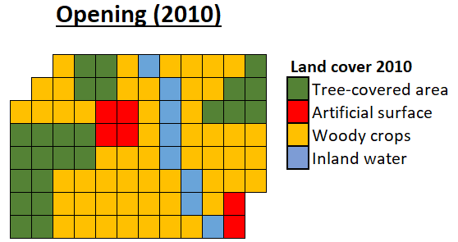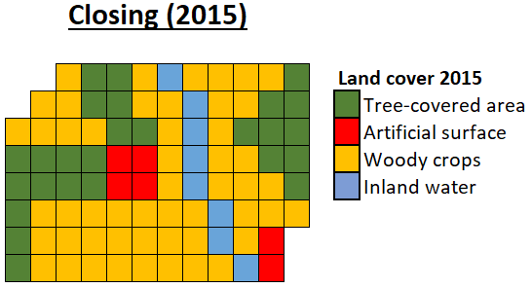

- Complete the basic land cover change account for 2010-2015 in hectares:
 | Tree-covered area | Artificial surface | Woody crops | Inland water | Total
Opening stock | 24 | 6 | 53 | 8 | 91
Additions to stock | 5 | 2 | 3 | 0 | 10
Reductions in stock | 3 | 2 | 5 | 0 | 10
Closing stock | 26 | 6 | 51 | 8 | 91

- Create a land cover change matrix for 2010-2015 in hectares based on your land cover change account and the maps.
Opening land cover | Closing land cover
 | Tree-covered area | Artificial surface | Woody crops | Inland water | Opening stock
Tree-covered area | 21 | 0 | 3 | 0 | 24
Artificial surface | 2 | 4 | 0 | 0 | 6
Woody crops | 3 | 2 | 48 | 0 | 53
Inland water | 0 | 0 | 0 | 8 | 8
Closing stock | 26 | 6 | 51 | 8 | 91

- Interpretation: Based on your land cover change matrix and maps, do you see any improbable changes that you would need to flag to the mapping authority? What else do you notice about the advantages/disadvantages of creating a land cover change account vs a change matrix?
The land cover change matrix indicates that we have 2 hectares that starts out as artificial surface at the beginning of the accounting period and is tree-covered area at the end of the accounting period. This would probably be considered an “improbable” transition in most cases. While a land cover change account is easier to interpret, it does not provide information on where the additions and reductions are coming from.

