Appendix E: China Indicators Testing Report

Report of the NCAVES Project

SEEA-linked Indicator Test Report

I. Guangxi pilot ecosystem classification systems and connections between such systems and SEEA classification systems

1.Guangxi ecosystem classification systems and ecosystem-extent accounts
Covering a total land area of 237,600 square kilometers, the landform of Guangxi Zhuang Autonomous Region mainly features vast mountains and sparse land, with mountains, hills and stone mountains accounting for approximately 70% of the total area.
According to the characteristics of land cover in Guangxi, Guangxi ecosystem is classified into forest ecosystem, grassland ecosystem, farmland ecosystem, wetland ecosystem, urban ecosystem and marine ecosystem. The six ecosystems are further divided into several sub-categories, forming detailed pan-ecosystem accounts. In 2017, the total area of the six ecosystems included in the assessment range was 213,200 square kilometers (excluding urban villages, industrial and mining land, transportation land, water conservancy facility land and other land areas in the data of land use changes of the natural resources authorities), accounting for around 90% of the total area of the region. Refer to the ecosystem-extent accounts in Table 1:

Table1 Farmland Ecosystem Extent Account(Unit: Hectare)
 |  | Opening extentt | Additions to extent | Reduction in sextent | Closing extent | Ecosystem area
A | Wet crops | 2178845 | 8452 | 7603 | 2179694 | 4862276
 | Dryland crops | 2689121 | 5089 | 11628 | 2682582
B | Chinese fir | 1856480 | 64279 | 51651 | 1869108 | 14473261
 | Pines | 2141764 | 101261 | 147063 | 2095962
 | Hard broadleves | 1967204 | 76095 | 196301 | 1846998
 | Soft broadleves | 1289836 | 221385 | 122473 | 1388748
 | Eucalyptus species | 2118773 | 206935 | 137112 | 2188596
 | Arbor economic forest | 734775 | 23732 | 34368 | 724139
 | Bamboo forest | 318545 | 22446 | 15055 | 325936
 | Shrub forest in artificial mounds | 90274 | 11914 | 13581 | 88607
 | Shrub forest in stone hills | 1557924 | 63482 | 89813 | 1531593
 | Shrub economic forest | 646523 | 80233 | 33423 | 693333
 | other forest communities | 1722989 | 82818 | 85566 | 1720241
C | Natural grassland | 5012 | 33 | 10 | 4936 | 1107039
 | Artificial grassland | 214 | 0 | 2 | 212
 | other Grassland | 1110223 | 1000 | 9431 | 1101891
D | Rivers | 285548 | 900 | 368 | 290080 | 611352
 | Lakes, | 462 | 3 | 0 | 465
 | Reservoirs | 170467 | 189 | 114 | 171542
 | Ponds | 176939 | 525 | 2232 | 170232
 | Ditches | 91886 | 82 | 385 | 91583
 | Inland beaches | 36536 | 74 | 511 | 36099
E | Mangroves | 9431 | 69 | 391 | 9109 | 93535
 | Coastal beaches | 84643 | 7 | 224 | 84426
F | Parks and green land | 24733 | 314 | 681 | 24366 | 24366
Other land |  | 2453713 |  |  | 2442382
Total |  | 23762860 |  |  | 23762860
Note: A represents farmland ecosystem, B represents forest ecosystem, C represents grassland ecosystem, D represents freshwater (wetland) ecosystem, E represents marine ecosystem, and F represents urban ecosystem.

2. Connections between Guangxi ecosystem classification systems and SEEA EEA classification systems
The correspondence between Guangxi ecosystem classification systems and the IUCN classification systems recommended in SEEA EEA is shown in Table 2. Among them, the forest ecosystem mainly corresponds to T1 and T3, and the grassland ecosystem corresponds to T4. Both ecosystems are in good agreement with the corresponding descriptions of the IUCN classification systems.
The IUCN classification systems are in absence of a distinct “agriculture”-themed type. The corresponding types of the farmland ecosystem are T7.1, T7.2, and T7.3 in the T7 intensive land-use biome; the corresponding types of the freshwater (wetland) ecosystem are mainly F1, F2, and F3. The greatest difference between these two categories and the IUCN classification systems is that rice paddies are classified into farmland ecosystem in Guangxi ecosystem classification systems, while the corresponding sub-category in IUCN is F3.3 rice paddies, which is included in the wetland ecosystem.
The marine ecosystem only includes FM1.2 and MFT1.2, which correspond to coastal shoals and mangroves, respectively. Only the land area in the marine ecosystem is calculated, and specific sea areas are not included; only the urban public green space is assessed in the urban ecosystem, which corresponds to T7.4 urban ecosystems in IUCN, hence T7.4 is separated from the T7 intensive land-use biome category and independently counted as the urban ecosystem area. Table 2 shows the correspondence between the two classification systems.
Table 2: Connections between the six Guangxi ecosystems and IUCN land types
Ecosystem types in Guangxi pilot system | Corresponding IUCN category | IUCN sub-categories
Forest ecosystem | T1. Tropical-subtropical forests biome | T1.1 Tropical-subtropical lowland rainforests
 |  | T1.2 Tropical-subtropical dry forests and scrubs
 |  | T1.3 Tropical-subtropical montane rainforests
 | T3. Shrublands and shrubby woodlands biome | T3.1 Seasonally dry tropical shrublands
 |  | T3.4 Young rocky pavements, lava flows and screes
Grassland ecosystem | T4. Savannas and grasslands biome | T4.1 Trophic savannas
 |  | T4.2 Pyric tussock savannas
Farmland ecosystem | T7. Intensive land-use biome | T7.1 Annual croplands
 |  | T7.2 Sown pastures and fields
 |  | T7.3 Plantations
 | F3. Artificial wetlands biome | F3.3* Rice paddies
Freshwater (wetland)  ecosystem | F1. Rivers and streams biome | F1.1 Permanent upland streams
 |  | F1.2 Permanent lowland rivers
 | F2. Lakes biome | F2.1 Large permanent freshwater lakes
 |  | F2.2 Small permanent freshwater lakes
 | F3. Artificial wetlands biome | F3.1 Large reservoirs
 |  | F3.2 Constructed lacustrine wetlands
 |  | F3.4 Freshwater aquafarms
 |  | F3.5 Canals and storm water drains
Urban ecosystem | T7. Intensive land-use biome | T7.4* Urban ecosystems
Marine ecosystem | FM. Transitional waters biome | FM1.2 Permanently open riverine estuaries and bays
 | MFT1. Brackish tidal biome | MFT1.2 Intertidal forests and shrublands
*: Discrepancies between Guangxi pilot ecosystem classification systems and IUCN classification systems

Table 3 Various Ecosystem-extent accounts of the IUCN system
 | T1.1 Tropical-subtropical lowland rainforests | T1.2 Tropical-subtropical dry forests and scrubs | T1.3 Tropical-subtropical montane rainforests | T3.1 Seasonally dry tropical shrublands | T3.4 Young rocky pavements, lava flows and screes | T4.1 Trophic savannas | T4.2 Pyric tussock savannas | T7.1 Annual croplands | T7.2 Sown pastures and fields | T7.3 Plantations | T7.4* Urban ecosystems | F1.1 Permanent upland streams | F1.2 Permanent lowland rivers | F2.1 Large permanent freshwater lakes | F2.2 Small permanent freshwater lakes | F3.1 Large reservoirs | F3.2 Constructed lacustrine wetlands | F3.4 Freshwater aquafarms | F3.5 Canals and storm water drains | F3.3* Rice paddies | FM1.2 Permanently open riverine estuaries and bays | MFT1.2 Intertidal forests and shrublands
Opening stock | 10427377 |  |  | 736797 | 1557924 | 1115235 | 214 | 2689121 |  |  | 24733 | 285548 |  | 462 |  | 170467 |  |  | 268825 | 2178845 | 84643 | 24733
Additions to stocks | 716133 |  |  | 92147 | 63482 | 1033 | 0 | 5089 |  |  | 314 | 900 |  | 3 |  | 189 |  |  | 607 | 8452 | 7 | 314
Reductions to stock | 704023 |  |  | 47004 | 89813 | 9441 | 2 | 11628 |  |  | 681 | 368 |  | 0 |  | 114 |  |  | 2617 | 7603 | 224 | 681
Closing stock | 10439487 |  |  | 781940 | 1531593 | 1106827 | 212 | 2682582 |  |  | 24366 | 290080 |  | 465 |  | 171542 |  |  | 261815 | 2179694 | 84426 | 24366

II. Water-related ecosystem extent

1. Sub-category accounts of Guangxi pilot freshwater (wetland) ecosystem
The scope of Guangxi pilot freshwater (wetland) ecosystem is divided according to the public blue space types and corresponding types of public blue space systems outlined in the national standard Land Use Status Classification (GB/T21010-2017) of the People’s Republic of China. Although the annex of the standard dictates that the “rice paddies” land type can be classified as “wetland” land use type, it is only for classification and not as a basis for departmental management. To avoid repetitive calculation, “farmland” is classified into the farmland ecosystem instead of wetland ecosystem in Guangxi pilot ecosystem classification systems. Refer to Guangxi freshwater (wetland) ecosystem-extent accounts in Table 4, and Guangxi freshwater (wetland) ecosystem-extent spatial account in Figure 1.
Table 4 Freshwater Ecosystem Extent Account (Unit: Hectare)
Freshwater (wetland) ecosystem sub-types | River surface | Lake surface | Reservoir surface | Pond surface | Ditches | Inland  shoals | Total
Code | GX0111 | GX0112 | GX0113 | GX0114 | GX0117 | GX0116
Opening stock | 285548 | 462 | 170467 | 176939 | 91886 | 36536 | 761838
Additions to stocks | 900 | 3 | 189 | 525 | 82 | 74 | -
Reductions to stock | 368 | 0 | 114 | 7232 | 385 | 511 | -
Closing stock | 290080 | 465 | 171542 | 170232 | 91583 | 36099 | 760001

2. Connections between Guangxi freshwater (wetland) ecosystem extent and water-related ecosystem extent in the IUCN
The classification standard of sub-types in the public blue space ecosystem in Guangxi pilot system is similar to that of the IUCN, and basic correspondence can be established. Refer to the specific correspondence in Table 5. The greatest difference is that the ecosystem sub-type of “rice paddies” corresponds to F3.3 rice paddies in the IUCN, which belongs to the wetland ecosystem type.
Table 5 Connections between Guangxi freshwater (wetland) ecosystem types and the IUCN land types
IUCN classification systems |  | Guangxi pilot classification systems
Ecosystem types | Sub-types | Ecosystem types | Sub-types
F1. Rivers and streams biome | F1.1 Permanent upland streams | Freshwater (wetlands)  GX0110 | GX0111 rivers
 | F1.2 Permanent lowland rivers
F2. Lakes biome | F2.1 Large permanent freshwater lakes |  | GX0112 lakes
 | F2.2 Small permanent freshwater lakes
F3. Artificial wetlands biome | F3.1 Large reservoirs |  | GX0113 reservoirs  GX0114 ponds
 | F3.2 Constructed lacustrine wetlands
 | F3.4 Freshwater aquafarms
 | F3.5 Canals and storm water drains |  | GX0116 inland shoals  GX0117 ditches

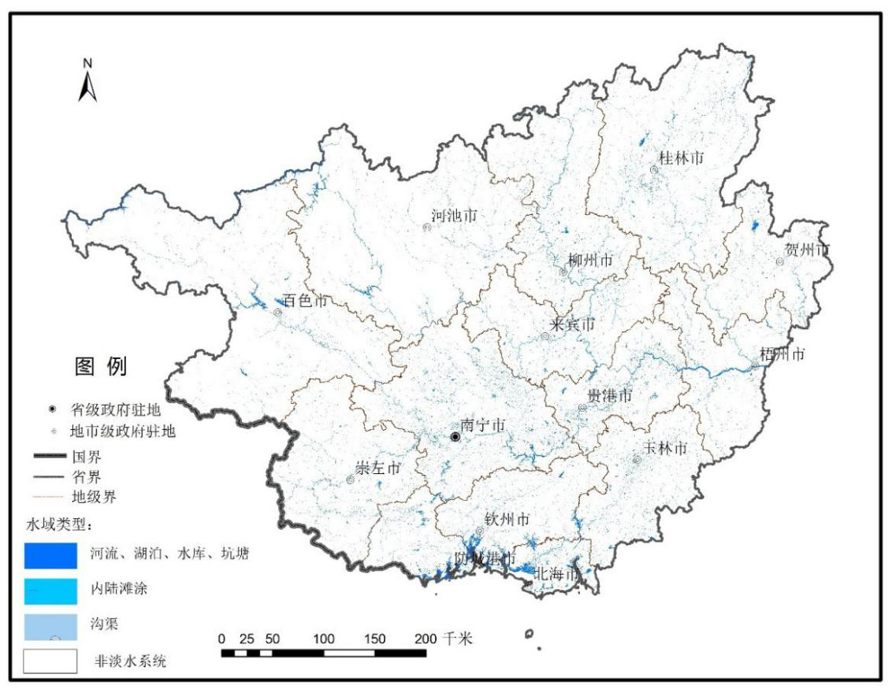
Figure 1 Mapping of Guangxi wetland ecosystem extent (2017)

Table 6 shows the wetland ecosystem-extent accounts in the IUCN system. After F3.3 is included in the wetland ecosystem, its scope has changed significantly. F3.3 occupies a larger area in Guangxi region than the total areas of all other wetland types.
Table 6 Wetland ecosystem-extent accounts calculated by the IUCN system
Unit：10^{×4} ha
 | F1.1 Permanent upland streams | F1.2 Permanent lowland rivers | F2.1 Large permanent freshwater lakes | F2.2 Small permanent freshwater lakes | F3.1 Large reservoirs | F3.2 Constructed lacustrine wetlands | F3.4 Freshwater aquafarms | F3.5 Canals and storm water drains | F3.3* Rice paddies
Opening stock | 285548 |  | 462 |  | 170467 |  |  | 268825 | 2178845
Additions to stock | 900 |  | 3 |  | 189 |  |  | 607 | 8452
Reductions to stock | 368 |  | 0 |  | 114 |  |  | 2617 | 7603
Closing stock | 290080 |  | 465 |  | 171542 |  |  | 261815 | 2179694
*: In the IUCN system, the wetland ecosystem includes the sub-type of F3.3 rice paddies

Table 7 shows the difference among Guangxi pilot freshwater (wetland) ecosystem, the IUCN wetland ecosystem-extent accounts and the SDG 6.6.1 indicators.
Table 7 Connections between Guangxi pilot wetland ecosystem and the IUCN wetland ecosystem-extent accounts
 | (+/) | 2016 | 2017 | SDG6.6.1
Wetland ecosystem — GX Es | - | 456477 | 462087 | -1.23
Plus  Extent of wetland in F3.3 Rice paddies | (+) | 2178845 | 2179694
Wetland ecosystem — IUCN Es |  | 2635322 | 2641781 | -0.25

III. Forest ecosystem extent

1. Definition and sub-type accounts of Guangxi pilot forest ecosystem
Guangxi pilot forest ecosystem extent is defined with reference to the national standard Technical Regulations for Continuous Forest Inventory (GB/T38590-2020) of the People’s Republic of China and Technical Regulations for Continuous Forest Inventory (2014).
The scope of forest consists of arbor forests, bamboo forests (mangroves are classified into marine ecosystem for correspondence to the IUCN classification) and shrublands, as well as forests and fields of which the type is not specified in the state-owned land use type. Refer to the specific forest ecosystem area and sub-type accounts in Table 8, and Guangxi forest ecosystem space accounts in Figure 2.
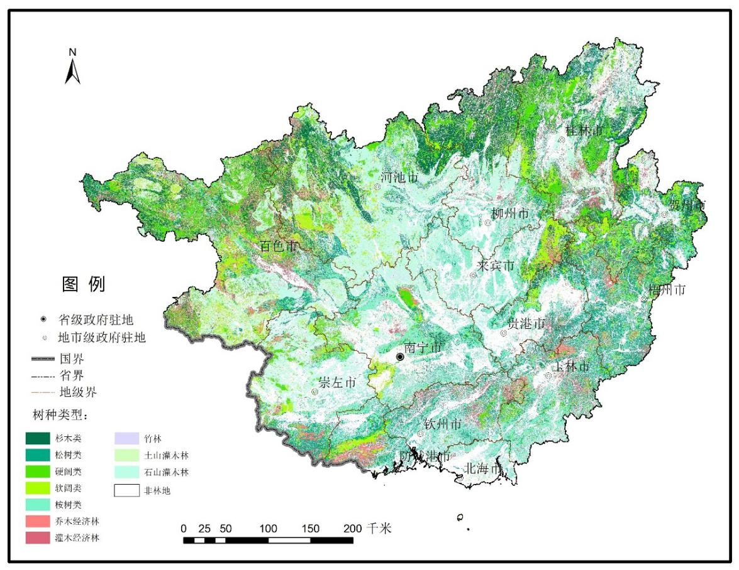
Figure 2 Mapping of Guangxi forest ecosystem extent (2017)

Table 8 Forest ecosystem-extent accounts (unit: 10^{×4} ha)
Forest type |  | Code | 2016 | Additions to stock | Reductions to stock | 2017
Arbor forest | Chinese fir forests | GX3001 | 185.65 | 6.43 | 5.17 | 186.91
 | Pine forests | GX3002 | 214.18 | 10.13 | 14.71 | 209.6
 | Hard broad-leaved forests | GX3003 | 196.72 | 7.61 | 19.63 | 184.7
 | Soft broad-leaved forests | GX3004 | 128.98 | 22.14 | 12.25 | 138.87
 | Eucalyptus forests | GX3005 | 211.88 | 20.69 | 13.71 | 218.86
 | Arbor economic forests | GX3006 | 73.48 | 2.37 | 3.44 | 72.41
Bamboo forest | Bamboo forest | GX3008 | 31.8545 | 2.2446 | 1.5055 | 32.5936
Shrublands | Earth mountain shrublands | GX3009 | 9.03 | 1.19 | 1.36 | 8.86
 | Stone mountain shrublands | GX3010 | 155.79 | 6.35 | 8.98 | 153.16
 | Economic shrublands | GX3007 | 64.65 | 8.02 | 3.34 | 69.33
Other forests |  | GX3000 | 172.3 | 8.28 | 8.56 | 17.2
Total |  |  | 1444.51 | 105.46 | 102.64 | 1447.33

2. Connections between Guangxi pilot forest ecosystem area and the IUCN classification systems
The geographical location of Guangxi is between 104°26'E-112°04'E and 20°54'N-26°20'N. According to the classification of China’s climate zone, most of the areas are in the south subtropical zone, except for a small part in the north which belongs to the mid-subtropical zone and the southern marginal zone which belongs to the tropical zone. Therefore, the corresponding forest ecosystem belongs to the range of T1 and T3 in the IUCN, refer to the specific correspondence in Table 9.
Table 9 Connections between Guangxi forest ecosystem types and the IUCN land types
IUCN classification systems |  | Guangxi pilot classification systems
Ecosystem types | Sub-types | Ecosystem types | Sub-types
T1. Tropical-subtropical forests biome | T1.1Tropical-subtropical lowland rainforests  T1.2Tropical-subtropical dry forests and scrubs  T1.3 Tropical-subtropical montane rainforests | Forests GX0030 | GX3001 Chinese fir forests
 |  |  | GX3002 pine forests
 |  |  | GX3003 hard broad-leaved forests
 |  |  | GX3004 soft broad-leaved forests
 |  |  | GX3005 eucalyptus forests
 |  |  | GX3006 arbor economic forests
 |  |  | GX3008 bamboo forest
 |  |  | GX3000 other forests
 | T1.4 Tropical heath forests |  | None
T3. Shrublands and shrubby woodlands biome | T3.1 Seasonally dry tropical shrublands |  | GX3007 economic shrublands
 |  |  | GX3009 earth mountain shrublands
 | T3.2 Seasonally dry temperate heath and shrublands |  | None
 | T3.3 Cool temperate heathlands |  | None
 | T3.4 Young rocky pavements, lava flows and screes |  | GX3010 stone mountain shrublands

Although the classification standard of sub-types in the forest ecosystem in Guangxi pilot system is consistent with that of the IUCN, and rigid correspondence cannot be established, the forest scope outlined in the forest ecosystem extent of Guangxi pilot system and in the IUCN system basically coincides. For example, there are sparse forests in some forests with a canopy coverage below 10% and are hence excluded from the forest ecosystem extent, which is consistent with the IUCN concept. It is worth mentioning that in Guangxi pilot system, T7.3 plantations is included in the agricultural ecosystem extent instead of the forest ecosystem extent, which is different from the description of IUCN. Table 10 shows the results of forest ecosystem-extent accounts and indicator SDG 15.1.1 calculated according to the IUCN system.

Table 10 Forest ecosystem-extent accounts calculated according to the IUCN system
Unit：ha
 | T1. Tropical-subtropical forests biome | T3.1 Seasonally dry tropical shrublands | T3.4 Young rocky pavements, lava flows and screes | SDG 15.1.1
Opening stock | 10427377 | 736797 | 1557924 | 60.79
Additions to stocks | 716133 | 92147 | 63482
Reductions to stock | 704023 | 47004 | 89813
Closing stock | 10439487 | 781940 | 1531593 | 60.91

Owing to the limitation of data sources, it is currently unavailable to calculate whether the specific flow direction of the forest type during opening and closing terms belongs to natural flow or man-made flow, and only the increase and decrease of the area are given. For the same reason, it is unavailable to isolate the specific type corresponding to T7.3 plantations in the farmland ecosystem, or to calculate the forest ecosystem asset accounts following T7.3.

IV. Public open spaces in urban areas
In the value accounting for Guangxi ecosystems, the urban ecosystem only includes the type of urban public green space. Owing to the limitation of data sources, the total area allocated to streets fails to be provided; the public blue space in urban areas also fail to be separated independently, but rather are unified in the wetland ecosystem for machine selection. When calculating the indicator SDG 11.7.1, the built-up area includes cities and organic towns, excluding rural areas, which is consistent with the definition of urban area in the IUCN. Refer to the connections between the urban ecosystem in Guangxi classification systems and related indicators in the IUCN in Table 11. Since Guangxi system only includes urban public green space, without urban public blue space and total area allocated to streets, the SDG 11.7.1 indicator here may be greatly underestimated.

Table 11 Connections between Guangxi urban ecosystem account and the IUCN system
Unit: ha
 | Urban public green space GX205  (GX Es) | Total urban extent  (GX & IUCN) | SDG 11.7.1
Opening stock | 24733 | 271911 | 0.086
Additions to stocks | 314 | 12696
Reductions to stock | 681 | 1054
Closing stock | 24366 | 283554 | 0.091

V. Land degradation using the SA
In terms of land degradation, the indications outlined in the SEEA EEA are mainly reflected in two aspects: ①land cover conversion: land cover transfer matrix; ②changes in ecosystem quality indicators: NPP, carbon storage, etc. A 5-year interval (2010-2015) between the reference period and the control period is recommended. As the ecosystem service value in 2016 and 2017 was accounted in Guangxi pilot, with a short interval, hence the variations are likely to result from normal fluctuations of the ecosystem. Consequently, the results are not indicative of the trend of long-term land degradation, and only facilitate preliminary discussion from the method.
In terms of land cover conversion, the aforementioned changes of forests, wetlands and urban ecosystem extent are all based on land cover changes. Owing to the limitation of data sources, currently only their change amount, change trend and remaining amount can be provided. The specific flow has not been calculated, and research on the land cover transfer matrix is ​​seeking new data sources.
In terms of ecosystem quality indicators, NEP is used for ecosystem productivity, and the carbon sequestration capacity of the ecosystem is estimated based on NEP. As the current accounting for NEP and carbon sequestration capacity adopts LUT (lookup table) method, the parameters used for the two years basically coincide, which fail to reflect the inter-annual changes in ecosystem quality. In follow-up research, remote sensing impacts or remote sensing products are to be used as data sources, and remote sensing technology will be used to extract NDVI so as to obtain detailed reflection of the ecosystem quality in the current period, and to track and reflect the temporal fluctuations and long-term trend of ecosystem quality.
In addition, in the research on ecological compensation of the Xijiang River basin, we have done some fundamental research on land cover types and historical transfer characteristics in the basin area during 1995-2015. Below is a brief introduction for reference of research method on land degradation.
Land cover types and historical transfer characteristics of the Xijiang River basin (data provided by the Research Center for Eco-Environmental Sciences, Chinese Academy of Sciences. )
During 1995-2015, the forest, cropland, wetland and builtup areas in the Xijiang River Basin showed an increasing trend. In 2015, various land types accounted for 54.95%, 28.06%, 3.12%, and 5.01% of the total basin area, (Table 3.1), increased by 3.26%, 0.20%, 0.54%, and 2.19% compared with 1995, respectively. The increase in forest is mainly from the transfer of grassland and cropland (Figure 3), the export area accounts for 42.36% and 52.69% of the newly added forest area, respectively. The increase in cropland is mainly from the transfer of forest, besides, the grassland-to-cropland transferred area accounts for 23.13% of the newly added cropland area, which is also an important source of cropland increase. The increase in wetland and built-up is mainly from the transfer of cropland, the export area accounts for 43.61% and 53.01% of the newly added area of wetland and built-up, respectively. In 2015, the grassland area accounted for 8.44% of the total basin area (Table 12), a decrease of 6.57% from 1995. Among them, forest and cropland were the main export destinations of grassland (Figure 3), and the export area accounted for 66.75% and 29.16% of the decreased area of grassland.
Table 12 Land cover area and proportion of Xijiang River basin in 1995 and 2015
Land cover | 1995 |  |  | 2015
 | Area  (km²) | Proportion  (%) |  | Area  (km²) | Proportion  (%)
Forest | 167380 | 51.68 |  | 177952 | 54.95
Grassland | 48628 | 15.02 |  | 27336 | 8.44
Cropland | 90219 | 27.86 |  | 90868 | 28.06
Wetland | 8354 | 2.58 |  | 10118 | 3.12
Builtup | 9143 | 2.82 |  | 16237 | 5.01
Bare land | 134 | 0.04 |  | 1347 | 0.42
Figure 3 Land cover transfer characteristics of the Xijiang River basin during 1995-2015

VI. Test conclusion
1. Ecosystem classification systems: the division of Guangxi pilot ecosystem classification systems is based on the land use status and the national standard Land Use Status Classification (GB/T21010-2017) of the People’s Republic of China. As a result, Guangxi is classified into six ecosystem types. SA uses the IUCN classification systems, although there is no rigid correspondence between the two in sub-types, the division and affiliation of major types are much similar. It is generally considered feasible to apply the IUCN classification systems to determine the extent of Guangxi ecosystems. However, since Guangxi only covers subtropical regions, the absence of temperate and frigid ecosystems fail to fully test the applicability of the IUCN classification systems. In addition, owing to the lack of monitoring data support in non-terrestrial areas, marine ecosystem was not thoroughly studied.
2. Ecosystem extent: the test has included the correspondence and differences between the forest ecosystem, wetland ecosystem, and urban ecosystem in Guangxi system and the corresponding ecosystem extent of the IUCN. Although the forest ecosystem has inconsistent classification standard of sub-categories, the overall scope of the two basically coincide. The biggest difference in defining the scope of the wetland ecosystem lies in the affiliation of the “farmland” ecosystem type, which was included in the “farmland ecosystem” in Guangxi pilot, and is accounted together with dryland crops, while it is included in the wetland ecosystem of the IUCN system, and is accounted together with other public blue spaces. In the accounting for the urban ecosystem extent, the IUCN has provided a detailed classification of urban extent and calculation method for the indicator SDG 15.1.1. Owing to the limitation of data sources in Guangxi system, only the urban public green space ecosystem was separated for independent accounting. It can be concluded that the accounting for urban ecosystem services in Guangxi system is insufficient and incomplete, hence a separate further study on the scope and service functions of the urban ecosystem is necessary in order to provide results corresponding to those in SA.
3. Land degradation: owing to the short interval of the accounting for Guangxi ecosystem value, the method of applying land cover changes and transfer flow to describe the land degradation trend has not been verified. The ecological quality indicators such as NPP, NDVI, and carbon stock dynamics also failed to indicate the land degradation trends, hence the definition and methods of land degradation using the SA needs further improvement. Meanwhile, the practice of Guangxi pilot work needs a longer period of time to complete the verification of trend.

