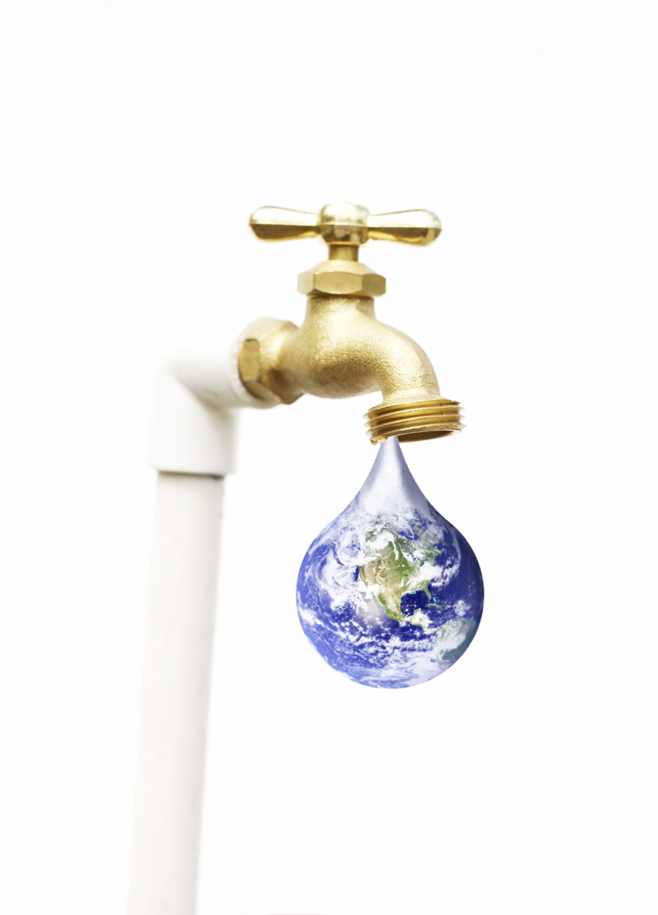
Making every drop count:
Water Accounting Workshop

Introduction

What is the purpose of this workshop?
The purpose of this workshop is to familiarise you with water accounting practices, so that at the end of the workshop you are capable of taking water data and compile water accounts at both the national level and river basin level. The tables follow the standard tables from SEEA-Water, which is the international statistical standard for organising physical and monetary data into water accounts.

Is this workshop for me?
This workshop is applicable to anyone engaged in water statistics or accounting or those wishing to understand these statistics.

What are the objectives of this workshop?
The objectives of this workshop are to give you the skills and knowledge required to take water data and organise this data into Physical supply and use tables for water.

What do I need to do?
To complete this workshop you need to complete a number of standard tables from the SEEA-Water. The exercises relate specifically to Physical supply and use tables for water.
Before starting the workshop please read “Welcome to the Republic of Blue”. This provides background to the Republic of Blue which is an imaginary country. It should be noted, however, that the data and other information presented are consistent with real data from real countries.
You should complete the exercises in the order they are presented, as they contain references to previous work and are related. The module commences with an introduction providing a brief outline of the exercises in the module. Each exercise is slightly more complex than the previous one.
For each exercise read the story, which has facts about the “Republic of Blue”, or one of its cities. Following the story are a set of instructions and questions that need to be completed, for example completing a table or questions asking for information contained in a table. You should plan an hour to complete each exercise.

Are there any references books I can use?
There are two documents that you could refer to when completing these exercises. The first is the SEEA-Water and the second is the International Recommendations for Water Statistics (IRWS). These documents are available online:
- SEEA-Water: http://unstats.un.org/unsd/envaccounting/seeaw.asp
- IRWS: http://unstats.un.org/unsd/envaccounting/irws/

Can I reuse or copy this workshop material?
The exercises of this workshop may be used by governments, businesses (e.g. consultancies) and individuals provided that they acknowledge that these exercises were created by the UNSD.

Acknowledgements
Michael Vardon, Jeremy Webb and Andrea Grozdanic from the United Nations Statistics Division, and Mr. Michael Nagy from the Environment Agency Austria.

Welcome to the Republic of Blue

About the Republic of Blue
The Republic of Blue is a small country (67,000 km³), bordered by the Westland on one side and the Cloudy Sea on the other. The population of the Republic of Blue is around 1,656,000 and it has a Gross Domestic Product of RBD$59,819 million (1 Republic of Blue dollar = 0.75 US dollars).
The Republic of Blue has one large river, the Beautiful River and three cities – Northville, Soda City and Green Port. Each city has its own particular patterns of water supply and use.
The government of the Republic of Blue decided to implement water accounts because water is a priority issue, both for the environment and the economy. The SEEA-W was selected as the framework to organise water data and answer key policy related questions such as:
- Which industries are using the most water?
- How much water do households use?
- What are the main sources of nitrate emissions?
- Who pays the most for water?

Figure 1: Map of the Republic of Blue.
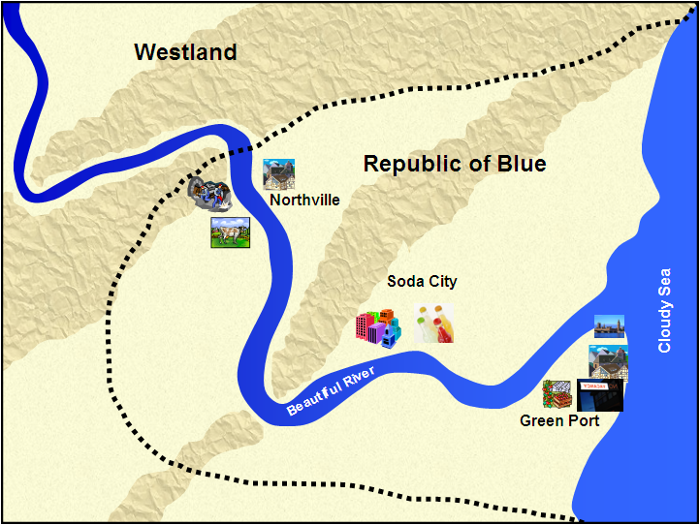
Water data is held by many different agencies across government including, for example, agencies responsible for the: environment, water, meteorology, hydrology, health, agriculture, energy, infrastructure and mines. Water supply and sewerage companies along with municipal authorities also had significant amounts of data on water.
The University of the Republic of Blue also holds research data on water, for example agriculture related water data, as well as information on water and sanitation and monitoring records from the Beautiful River.
At the direction of the Government, all government agencies (at the national and local levels) have made an inventory of available data, and mapped the data they have.
Each agency agreed to make their water data available for the water accounts. These data sharing agreements at the high level were required to ensure sufficient data was available to fill the accounts, and to ensure a complete picture of the water situation in the Republic of Blue could be built. The University also agreed to share its data.
In addition to the water information already mentioned, the National Statistics Office has provide some summary information regarding the three cities in the Republic of Blue. This information is presented below.

Soda City
Soda City is upstream of Green Port and downstream from Northville.
Soda City has the following characteristics:
- A population of 185,000 people
- An economy consisting of
  - Manufacturing industries (ISIC 10-33), including soft drink manufacture (part of food and beverage manufacture, ISIC 11)
  - Electricity (ISIC 35), in this case a hydro electric power plant
  - Water supply (ISIC 36)
  - Sewerage (ISIC 37)
  - Other industries (ISIC 38,39, 45-99), including transport (ISIC 49)
  - Households
- One water source – the Beautiful River

Northville
Northville is located upstream from Soda City. Northville is surrounded by farms as well as coal mine.
Northville has the following characteristics:
- A population of 215,000
- An economy consisting of
  - Agriculture (ISIC 01)
  - Coal mining (ISIC 05), one of the mining industries (ISIC 05-09)
  - Electricity (ISIC 35)
  - Water supply (ISIC 36)
  - Sewerage (ISIC 37)
  - Other industries (ISIC 38,39, 45-99)
  - Households
- Two water sources
  - Beautiful River (Surface water)
  - Groundwater

Green Port
Green Port is downstream from Northville and Soda City and it is the capital of the Republic of Blue. Green Port has the following characteristics:
- A population of 1,256,000
- A diverse economy consisting of
  - Agriculture (ISIC 01), mostly fruit and vegetable growing, including grapes for wine
  - Manufacture (ISIC 10-32)
  - Water supply (ISIC 36)
  - Sewerage (ISIC 37)
  - Other industries (ISIC 38, 39, 45-99), including water transport (ISIC 50), accommodation and food service (55-56), computer programming (ISIC 62) and public administration (ISIC 84)
  - Households
- One water freshwater source – the Beautiful River
- Water is also abstracted from the Cloudy Sea by the water supply industry (ISIC 36) for desalinisation.

A couple of important definitions

Water consumption: ‘the water that is evaporated, transpired or incorporated into products’

Water use: the water received by an institutional unit, either:
    - from another unit; or
    - extracted/abstracted directly from the environment

List of Acronyms and abbreviations
Listed below are some of the common acronyms and abbreviations used in the Republic of Blue.
CPC: Central Product Classification
GIS: Geographic Information System
IWRM: Integrated Water Resources Management
ISIC: International Standard Industrial Classification of All Economic Activities
MDG Indicators: Millennium Development Goal indicators
NHS: National Hydrological Service
SEEAW: System of Environmental-Economic Accounting for Water
SNA: System of National Accounts
UN: United Nations
UNSC: United Nations Statistical Commission
UNSD: United Nations Statistics Division

Physical supply and use tables for water

Introduction

What will I learn from these exercises?
These exercises will strengthen your understanding of the physical supply and use tables for water, and provide you with the skills and knowledge required to organise water data in these tables.

What can I use physical supply and use tables for?
Physical supply and use tables can be used to answer questions such as:
- Who uses water?
- How much water do they use?
- Who supplies water?
- How much water do they supply?

What do I need to do?
Please complete the three exercises in the following order:
- Exercise 1 – Soda City: An example of the physical supply and use tables
- Exercise 2 – Northville: Completing the physical supply and use tables
- Exercise 3 – Green Port: Populating the physical supply and use tables
Read the information at the beginning of the exercise before attempting to fill the tables or answer the questions.
The exercises become progressively more complex and you should plan to take about an hour for each exercise.
For a more complete understanding of the information systems described in this workshop please see Chapter 3 of the SEEA-W, as this chapter is all about the physical supply and use tables. Also see the IRWS which shows the link between data items defined in the IRWS (Chapter IV) and the SEEAW standard tables (Annex IV) including the physical supply and use tables.

How can I check my answers?
The completed tables and answers to the questions are available at the end of the workshop.

Exercise 1: Soda City: An example of the physical supply and use of water

Introduction
The supply and use of water in Soda City are shown in Figure 2. Note that the flows are shown in millions of meters cubed (=1,000,000 m³). Also note that the solid dark blue lines represent raw and potable (drinking) water flows, the red lines represent (untreated) wastewater flows and the light blue lines represent treated wastewater that is returned to the environment.

Water supply and use in Soda City
The water supply industry (ISIC 36) abstracts 144,000,000 m³ from the Beautiful River for the purpose of distribution. Of the 144,000,000 m³ abstracted, 119,000,000 m³ of water is supplied to industries and households. In the supply of this water, 17,000,000 m³ is lost through leaky pipes to groundwater. These are not classified as losses but the volume is assumed to return to groundwater and is classified as a return to the environment.
The largest water user in Soda City is the Electricity industry, which uses a total of 330,000,000 m³ of water. However, as nearly all of the water abstracted for hydro-power generation is returned to the Beautiful River, water consumption is 9,000,000 m³. The industry with the highest water consumption is soft drink manufacture which is part of the food and beverage manufacturing industry (ISIC 11).
The sewerage industry receives 22,000,000 m³ of wastewater for treatment and disposal from industries and households. Of this, 20,000,000 m³ is treated and returned to the environment.
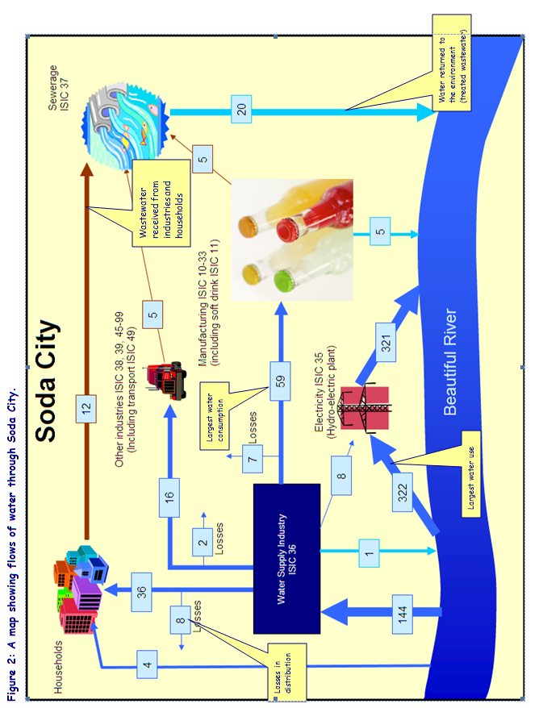

Questions on Soda City

- How much water does the electricity industry (ISIC 35) abstract from the environment?

- How much water do households receive from other economic units?

- How much water does the water supply industry (ISIC 36) distribute/supply to users (i.e. households and businesses)?

- How much water do the “other” industries (ISIC 38, 39, 45-99) return to the environment?

- Which industry uses the 2nd greatest amount of water?

- Which group of industries consumes the 2nd greatest amount of water?

- In the manufacture of soft drink, the industry that consumes the most water, how do you think the water was consumed?

Exercise 2: Northville: Completing the physical supply and use tables

Water supply and use in Northville
The physical flows of water in Northville are represented in Figure 3 and in Table 1. Note that the flows are shown in millions of meters cubed (=1,000,000 m³) and that Table 1 is currently incomplete.
There are two water suppliers (ISIC 36) in the Northville area. One water supplier is for the town of Northville, supplying both industries and households, while the second supplies only farms with water for irrigation. Together these water suppliers (ISIC 36) abstract 229,000,000 m³ of water. The water for irrigation is mostly supplied through open channels. Losses due to leaky pipes and from the open channels to groundwater are shown in the physical supply table (Line 5.a.2), but those due to evaporation are not shown in the physical supply and use tables. The supply of water losses from evaporation is large, because of the use of open channels.
The agricultural industry (ISIC 01) uses the largest amount of water (290,000,000 m³, Line 3) as well as consuming the largest amount of water (249,000,000 m³, Line 7).
The mining industry abstracts 9,000,000 m³ of water from the environment (Table 1, line 1). Of this amount 3,000,000 m³ is groundwater (Table 1, line 1.i.2) which has to be removed in order to allow the mining to occur (this is know as mine de-watering).
The electricity industry abstracts 2,000,000 m³ (Table 1, line 1) for use as cooling water. All of the cooling water is returned to the environment. The electricity industry uses an addition 1,000,000 m³ from the water supply industry (Table 1, line 2) for cleaning, drinking water and sanitation. The plant has its own sewerage treatment facilities and the water from this is used to maintain extensive gardens around the power plant, so there are no discharges to sewerage (ISIC 37).
Households use 29,000,000 m³ of water in Northville (Table 1, line 3). A part of population lives away from the town centre, on farms or on rural residential properties, and these households rely mostly on groundwater (8,000,000 m³, Table 1, line 1.i.2). These households also return some water to the environment (see Figure 3).
Figure 3: A map showing flows of water through Northville.
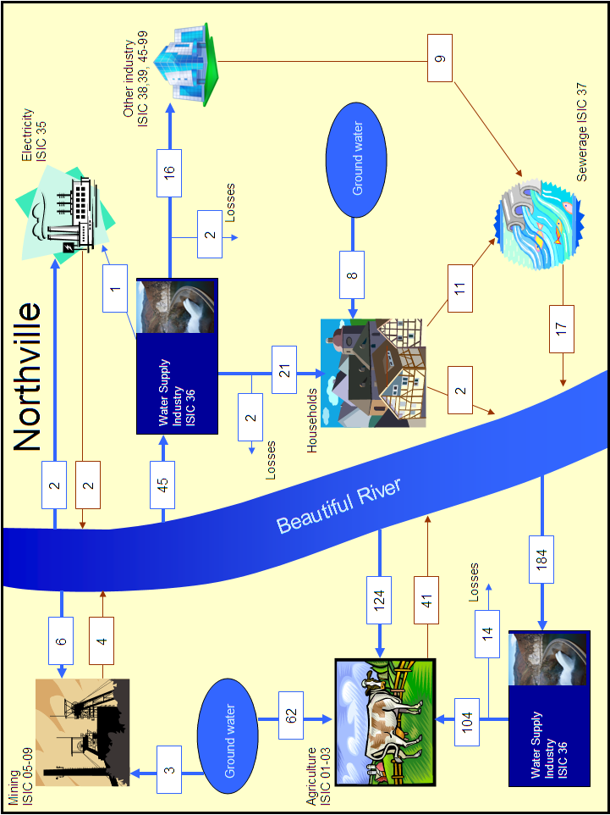
Table 1: Northville physical supply and use tables.
Note there are two water suppliers in the Northville area

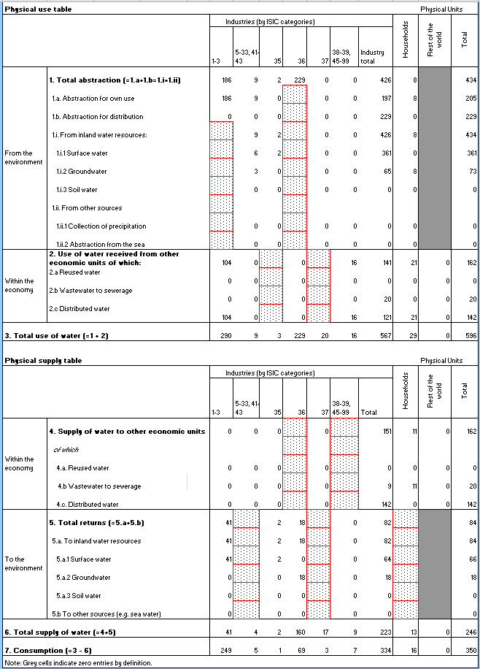
Largest water use
Largest water consumption
These are the losses. Note that these are from two sources. 14 from the supply to agriculture and 4 from the supply to households and other industries

Exercise and questions on Northville
Use the diagrams showing the physical water supply and use around Northville to fill in the gaps in the physical supply-use table. The gaps in the table are indicated by boxes filled with dots, like this:

Use the completed Table 1, Figure 3 and the information about Northville provided above to answer the following questions.

- How much water does agriculture (ISIC 01) abstract from the environment?

- Of the water abstracted by agriculture (ISIC 01) how much is from groundwater?

- In Northville, who supplies wastewater to the sewerage industry (ISIC 37)?

- How much water do households receive from other economic units?

- How much water could potentially be supplied as reused water by the sewerage industry (ISIC 37) rather than be returned to the environment?

- If the sewerage industry (ISIC 37) was to supply reused water to other industries (ISIC 38, 39, 45-99) with 5,000,000 m³ of reused water, in what column and line would the supply be recorded?

- If other industries (ISIC 38, 39, 45-99) were to use 5,000,000 m³ of reused water, in what column and line would the use be recorded?

- Why do you think the water supply industry consumes 69,000,000 m³ of water, the second most of all of the industries or households in Northville?

Exercise 3: Green Port: Populating the physical supply and use tables

Water supply and use in Green Port
The flows of water in Green Port are shown in Figure 4. Note that the flows are shown in millions of meters cubed (=1,000,000 m³).
Green Port has a diverse economy but is dependent on the Beautiful River for nearly all of its water. In order to reduce dependence on the Beautiful River the government has undertaken a number of initiatives:
- Constructed a desalination plant
- Encouraged the supply of water first used for cooling water by the electricity industry (ISIC 35) (2,000,000 m³)
- Promoted the supply of reused water, which is the treated sewerage water (20,000,000 m³) supplied by the sewerage industry, (ISIC 37) to other industries.
- Provided incentives to home owners to install rainwater tanks and 3,000,000 m³ was collected by households.
- Undertaken a program to replace leaky pipes to reduce the volume of losses by the water supply industry (ISIC 36)
These initiatives have meant that water users can receive water from several sources and from sources other than the water supply industry (ISIC 36). Also note that in Green Port there are two establishments of the water supply industry (ISIC 36). One abstracts water from the Beautiful River while the other is a small desalinisation plant that abstracts salt water from the sea.
Green Port is on the Cloudy Sea and as such many of the returns of water from the economy to the environment, specifically to the sea (i.e. not to the inland water resources).

Figure 4: Map of water flows through Green Port.
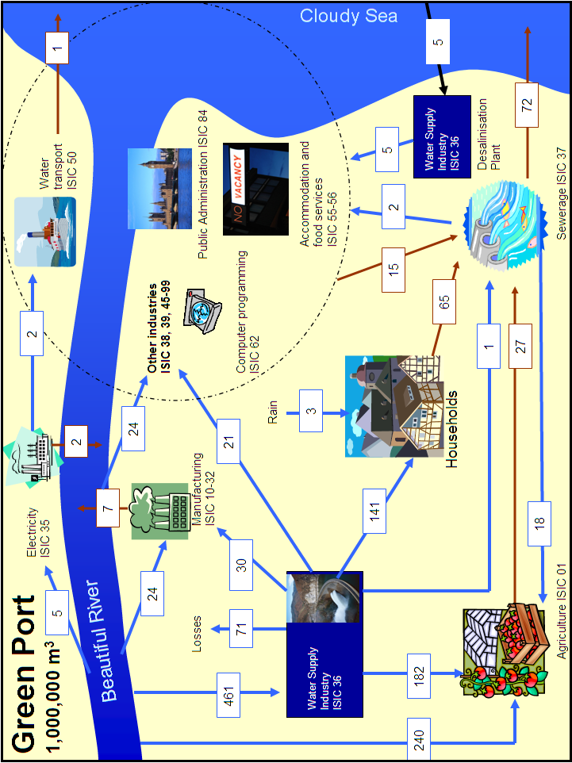
Table 2: Green Port physical supply and use tables

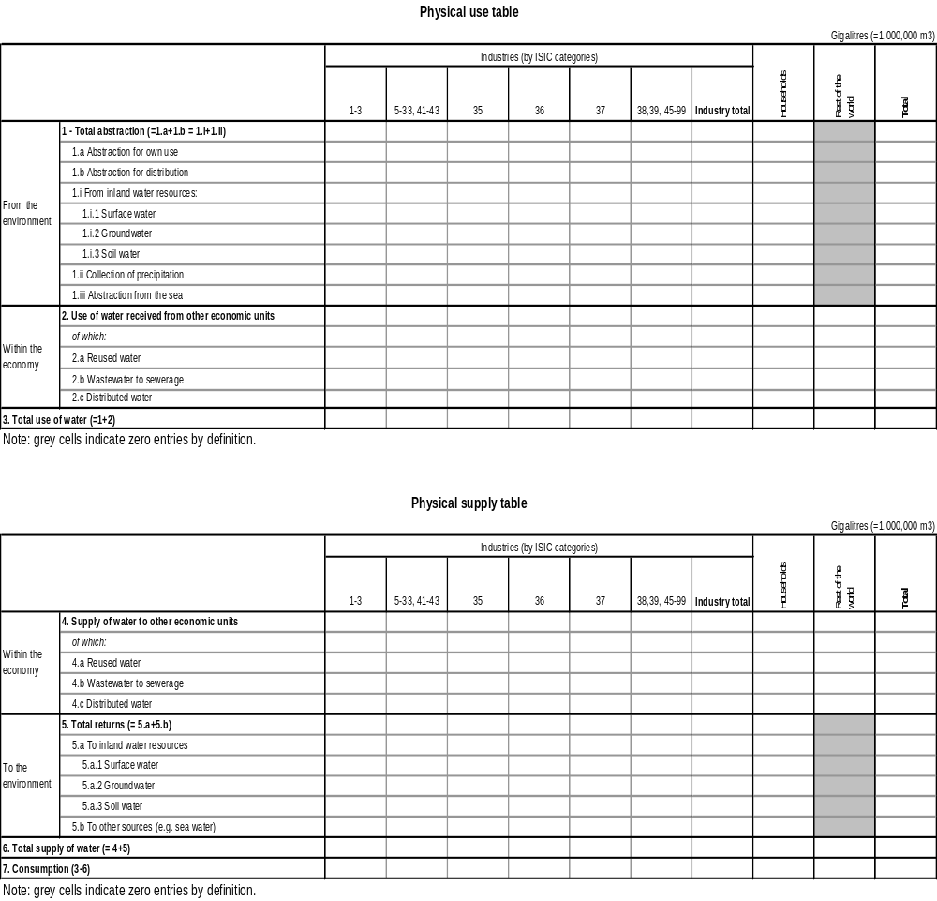

Exercise and questions on Green Port
Use the diagram (Figure 4) showing the physical water supply and use of Green Port to fill the physical supply-use table (Table 2). In the supply table, assume that the losses from the water supply industry (ISIC 36) are all returns to groundwater.
Be careful of the other industries (ISIC 38, 39, 44-99) which includes the industries water transport (ISIC 50), accommodation and food service (ISIC 55 and 56) computer programming (ISIC 62) and public administration (ISIC 84). These are all grouped together and this is indicated by them all being within the dotted circle in Figure 4. Also other industries (ISIC 38, 39, 44-99) abstract water directly from the Beautiful River as well as receiving water from four other sources.
Use the completed Table 2 and the information above to answer the following questions.

- In Green Port, which industries abstract water from the environment?

- How much water does agriculture (ISIC 01) receive from other economic units?

- From which industries do the other industries (ISIC 38, 39, 45-99) receive water?

- How much additional water (i.e. more than is currently supplied) could be supplied as reused water by the sewerage industry (ISIC 37)?

- What two water sources (i.e. abstractions from the environment) are used in Green Port that are not used in Soda City or Northville?

- Which industry or household uses the most water?

- Which industry or household consumes the most water?

- Of the total water use, what percentage is accounted for by:
- Collection of precipitation by households
- Use of reused water (supplied by ISIC 37)
- Supply of water used first for cooling by the electricity industry (ISIC 35)
- Losses by the water supply industry (ISIC 36)

This workshop was developed by the United Nations Statistical Division (UNSD)

