**The Unu-Water Exercise**

**A Step-by-Step**

**Introduction to**

**Environmental –Economic Accounts**

**for Water**

**(SEEA-Water)**

**Workbook**

13 June 2014

Rev 8

(Translation was done with version 2)

The following are the standard definitions provided in the System of Environmental-Economic Accounting, Central Framework (SEEA-CF). The specific paragraphs in the SEEA-CF, where the definitions can be found, are provided in parenthesis:

|  |  |
| --- | --- |
| Abstraction | Abstraction is defined as the amount of water that is removed from any source, either permanently or temporarily, in a given period of time.  Water used for hydroelectric power generation, is considered as abstraction and is recorded as a use of water by the abstractor. Water abstracted but not used in production, such as water flows in mine de-watering, are recorded as natural resource residuals. Water abstraction is disaggregated by source and by industry. (SEEA-CF 3.195) |
| Final Water Use | Final Water Use is equal to evaporation, transpiration and water incorporated into products. (Also referred to in the SEEA-Water as “water consumption”) (SEEA-CF 3.222) |
| Return Flows of Water | Return flows of water comprise water that is returned to the environment. (SEEA 3.210) |

**Module I: Basic understanding of the water cycle in the economy**

Template for diagram of water flows in the economy

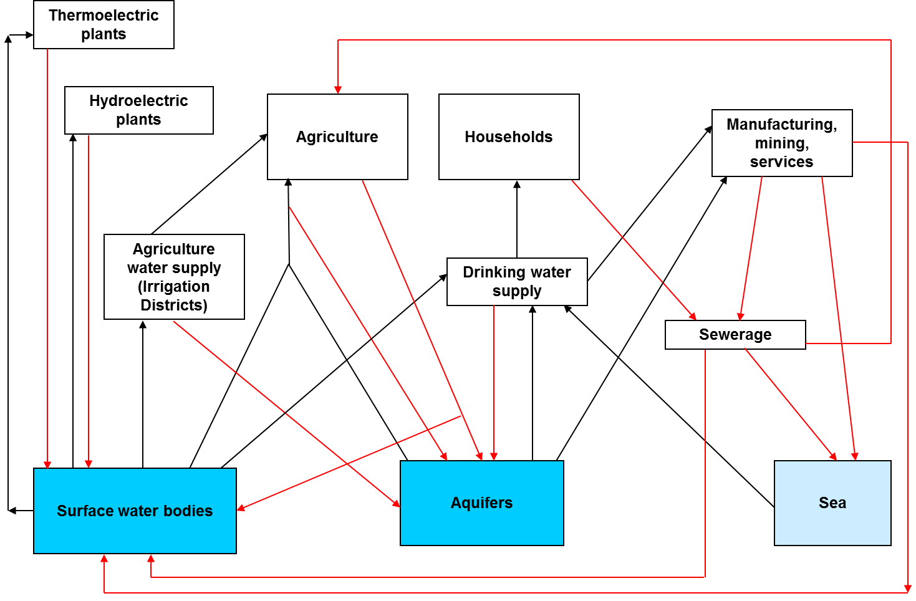

**Module II: Basic understanding of the natural water cycle**

Template for diagram of water flows in the natural water cycle

