The Unu-Water Exercise
(Excerpt of modules 1, 2, and 6 for 2016 SNA SEEA Training course)

A Step-by-Step
Introduction to
Environmental –Economic Accounts
for Water
(SEEA-Water)

20 June 2014
Rev 31
(translations were based on revision 24)
Presentation

This example provides a collection of exercises intended to assist statisticians and water experts in the use of standardized statistical tools for developing comprehensive, consistent and comparable policy relevant information about water. The example is a complement to the Guidelines for the Collection and Compilation of Water Accounts and Statistics developed by the UN Statistics Division.

The exercises gradually add more elements and details to be considered for understanding the water problems in the fictitious country of the example. Throughout the exercises the reader will be able to appreciate the value of the statistical tools for integrating complex sets of apparently unrelated data.

Acknowledgements

This example has been designed by UNDESA-Statistics Division. Throughout the design and revision process, the following people have participated: Alessandra Alfieri, Apolonio Basilio, Karima Bensouda, Ashraf Dweikat, Raúl Figueroa, Federico González-Medrano, Cor Graveland, Fabio Herrera-Ocampo, Marco A. Jaubert-Vincenzi, Ivo Havinga, Laura Johnson, Mark Lound, Omar Malik, Salvador Marconi, Ricardo Martinez-Lagunes, Michael Nagy, Marco Neves, Allan Ramírez, Leila Rohd-Thomsen, Gulab Singh, Anand Sookun, Francois Soulard, Kristina Taboulchanas, Sokol Vako, Michael Vardon, Moshe Yanai.
Unu: the country

Unu is a country located somewhere far and away. The full name of Unu is Unupacha, which in the local language means land of water. The name is not due to the abundance of water in the country, but rather because water is considered very important for the inhabitants of Unu.

Unu is a relatively small country. It has a total land area of 16 000 km² and a population of 6.25 million inhabitants. The economy of Unu is well diversified. Agricultural, livestock and forestry activities account for approximately 17% of the Gross Domestic Product (GDP), and employs 25% of the economically active population. Manufacturing accounts for approximately 23% of GDP, and employs 13% of the active population.

In terms of water, the country enjoys a fair amount of rainfall, 800 mm on average per year. Furthermore, 1 000 million cubic meters of water per year flow from the neighboring upstream country to Unu. For the purposes of water management, the country is divided into four water management regions as shown in the figure below. Only one region has access to the sea. The country only has a coastal line of 800 km. There are pollution problems, especially in the Eastern region, due mainly to the fact that not all wastewater collected in sewers is properly treated before discharging it to the rivers and streams of Unu.

Water is abstracted from the aquifers and surface water bodies to irrigate 465 000 ha of corn and sugarcane crops, to provide drinking water to the population, for use in the different industries, as well as for cooling of thermoelectric power plants. There is one desalination plant in the coastal region that abstracts water from the sea to complement the abstractions of inland water resources used for drinking water supply. In addition, several “run-of-the-river” hydroelectric plants turbinate the water of the rivers to produce electricity. 86% of the population is connected to the drinking water supply network, and 75% to the sewers.

In the past five years, a drought has raised serious concerns in the Government of Unu. Several cities of the country have experienced water shortages. Farmers have seen the productivity of their fields drop dramatically, due to lack of water for irrigation in the most critical weeks of the year. Besides, the government wants to give universal access to water and sanitation to the inhabitants of Unu, which will require investments to expand the water supply and sewerage networks, as well as additional volumes of water from the aquifers and surface water bodies.

The Ministry of Water Resources (UMWR), the Meteorological Office (MeteoU), and the Central Bureau of Statistics (CBSU), have been given the mandate to establish a water information system that will help the government in the design and evaluation of the new water policies that the government will put in place in order to secure sustainable water for the country.

UMWR, MeteoU, and CBSU have created a working group that will design the new water information system based on water accounting and statistical standards. Each agency is responsible for the quality of the data in the area of their competence.

The following exercises show the different sets of information analyzed by the working group in order to create the new information system, using a modular approach of increasing complexity. Additional information will be provided as needed.

Map of Unupacha showing the four water management regions

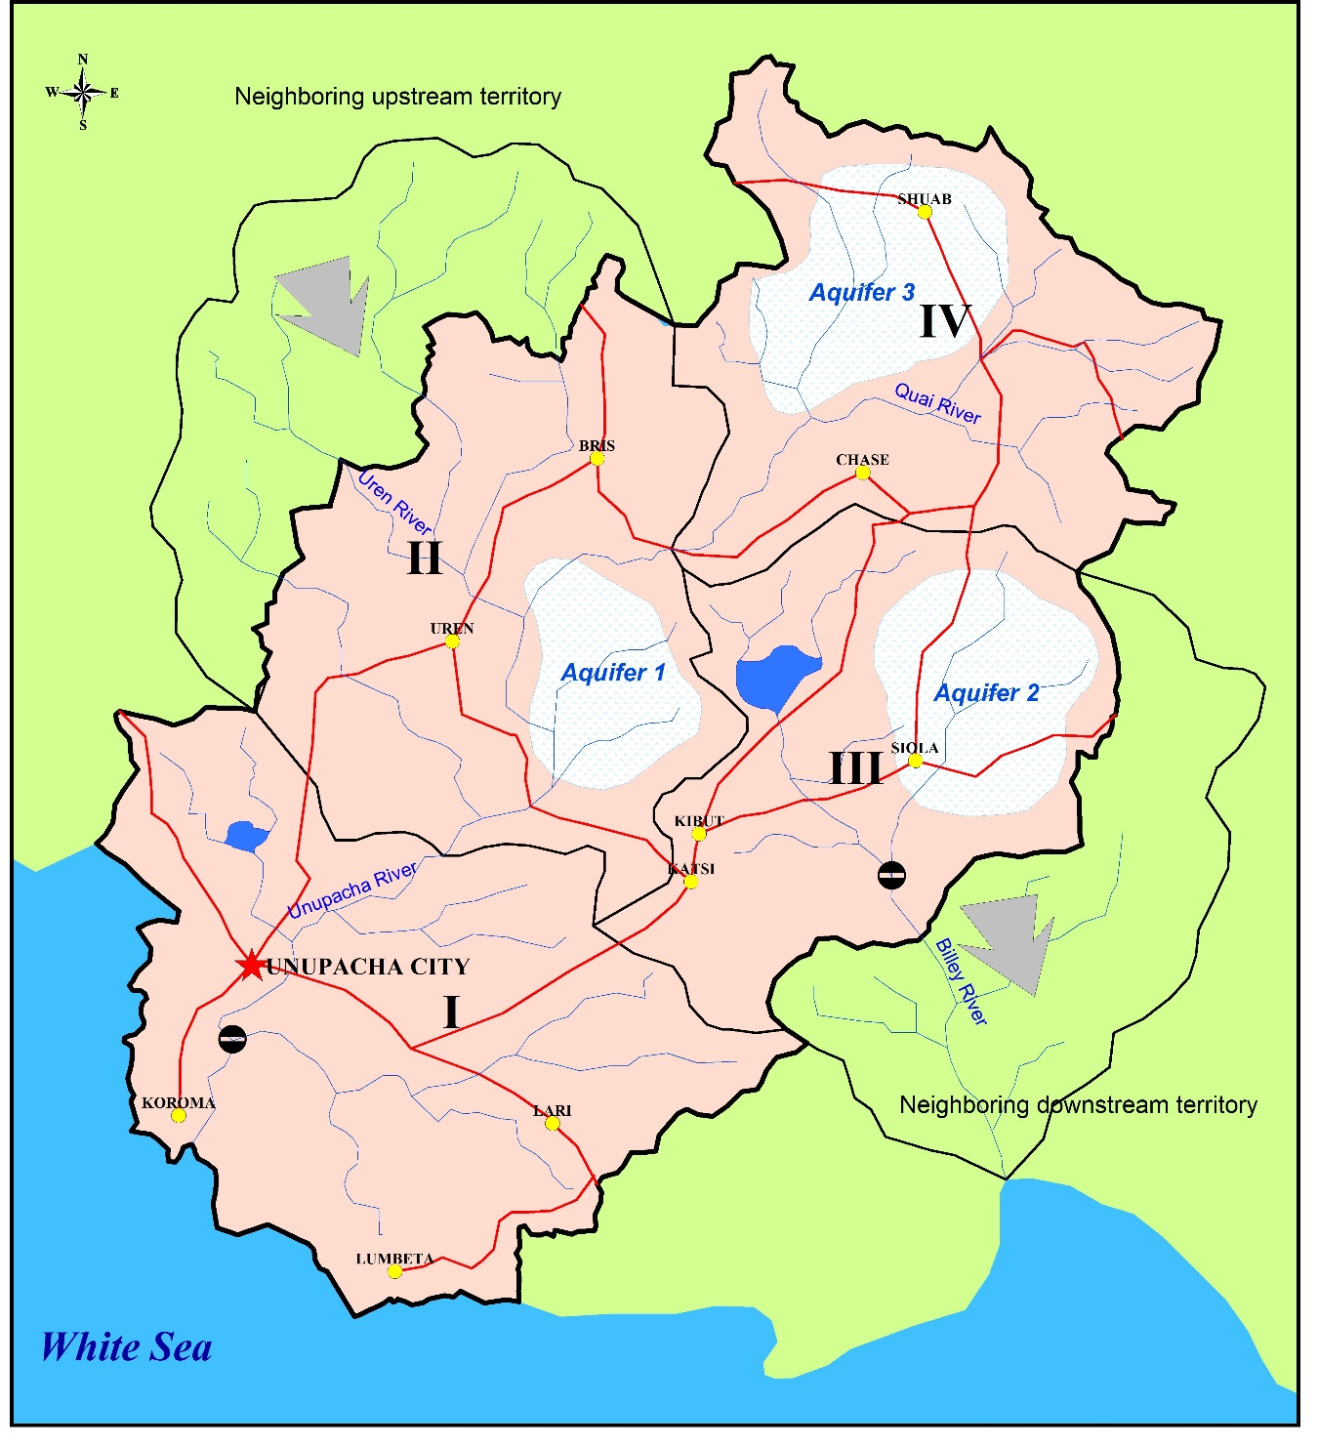

Module I: Basic understanding of the water cycle in the economy

The starting point will be the water cycle in the economy, which will allow us to determine how much water is abstracted from the environment, and how much water returns to the environment. With this information, in the next module, a more complete understanding of the water cycle will be sought.

It is estimated that the irrigation districts, which supply water to most of the farms, abstract 1 436 million cubic meters of water per year from the rivers, lakes and artificial reservoirs of Unu. About 22% of the water abstracted is lost in the canals that convey water to the fields.

There are also independent farmers that abstract their own water. The abstraction from surface waters by independent farmers is estimated to be 345 million cubic meters per year (hm³/year), and the abstraction of groundwater is 155 hm³/year. About 10% of the total water abstracted is lost before reaching the fields. Some fields are irrigated with 40 hm³/year of treated wastewater collected in the sewers of Unu.

Water utilities abstract 420 hm³/year of surface water and 200 hm³/year of groundwater to supply the cities of Unu with drinking water. Water utilities also desalinate 39 hm³/year of sea water to complement the abstractions of surface and groundwater. It is estimated that 190 hm³/year of water are lost due to leaks in the water supply network. It is estimated that 350 hm³/year of water are delivered to households and the rest is delivered to the different users connected to the network.

The businesses that are not connected to the water supply network have their own wells, which abstract about 83 hm³/year of groundwater.

There are thermoelectric plants in Unu that abstract 650 hm³/year of surface water for cooling. There are also hydroelectric plants that turbinate 19 600 hm³/year of water.

NOTE: 1 hm³ = 1 million cubic meters = 1 gigaliter = 1 GL.

Exercises

- Review the following standard concepts from the System of Environmental Accounts Central Framework (SEEA-CF): Abstraction, Final Water Use, and Return Flows of Water.

The following are the standard definitions provided in the System of Environmental-Economic Accounting, Central Framework (SEEA-CF). The specific paragraphs in the SEEA-CF, where the definitions can be found, are provided in parenthesis:

Abstraction | Abstraction is defined as the amount of water that is removed from any source, either permanently or temporarily, in a given period of time.  Water used for hydroelectric power generation, is considered as abstraction and is recorded as a use of water by the abstractor. Water abstracted but not used in production, such as water flows in mine de-watering, are recorded as natural resource residuals. Water abstraction is disaggregated by source and by industry. (SEEA-CF 3.195)
Final Water Use | Final Water Use is equal to evaporation, transpiration and water incorporated into products. (Also referred to in the SEEA-Water as “water consumption”) (SEEA-CF 3.222)
Return Flows of Water | Return flows of water comprise water that is returned to the environment. (SEEA 3.210)

- Make a diagram of all the interconnected flows of water with the information provided. Use the template provided.

Stretch Your Thinking

- Can you provide quantitative estimates of the information that is not provided and that is necessary to quantify all the flows of water, such as, water discharged to the sewers and returns to inland water resources? You can use coefficients to estimate the final water use (also known as water consumption).

The final water use or “water consumption,” can be estimated using coefficients determined specifically for each case. If the coefficients are not available locally, coefficients from other countries in the region may be used in a first stage, and then adjusted based on data from the country. For the purpose of this exercise, some arbitrary coefficients, based on international data, will be used, as described below

- Hydroelectricity: it will be assumed that all the water turbinated is returned to inland water resources after leaving the power plant.
- Thermoelectricity: it will be assumed that 95% of the water abstracted for cooling is returned to inland water resources. The rest, 5%, is evaporated.
- Households: it will be assumed that 80% of the water received goes to the sewers, the rest is evaporated.
- Agriculture: it will be assumed 40% of the water used (received from the irrigation districts and abstracted by agriculture) is returned to inland water resources.
- It will be assumed that the different industries and services, other than agriculture, discard 70% of the water received.

Regarding the destination of wastewater, some assumptions can be made based on the different discharges identified and/or the general known facts of the country or region. The following assumptions will be made for this exercise:

- The water discarded by industries and services is sent to the sewers, to the sea, and to surface water in equal proportions.
- 40 million cubic meters per year of the water discarded through the sewers is sent to agriculture for reuse (information provided in the statement of the problem). From the amount not sent to reuse half is sent to surface water bodies and half to the sea.
- 80% of the water discarded by agriculture goes to groundwater and 20% to surface water.

Please stop and check your solutions at this point. Answers to question 5 require assumptions which will feed through into the rest of the exercise.

Module II: Basic understanding of the natural water cycle

According to MeteoU, the average precipitation in Unu is 800 mm/year, which in volume is equivalent to 12 800 million cubic meters of water per year (hm³/year). This is the result of multiplying the average precipitation by the total area of the country (800 mm/year x 16 000 km2 x 1/1 000 hm³/km²/mm). UMWR estimates that 20% of the precipitation becomes surface runoff and 5% infiltrates to the aquifers, the rest evaporates or is transpired by vegetation. This means that the total volume of evapotranspiration in the country is about 75% of the volume of precipitation.

There is also a transboundary river that brings 1 000 hm³/year of surface water to Unu from upstream territories. Another transboundary river flows from Unu to downstream countries taking 700 hm³/yr.

Exercises

- Make a diagram that shows all the interconnected flows of water entering and leaving Unu, with the information provided. Use the template provided.

Module VI: Physical supply and use

The diagrams done in modules I and II are useful for constructing the physical supply and use tables, as well as the asset account.

Exercises

- Construct the supply and use tables using the information provided in module I. Use the template provided.

“run-of-the-river” means that no storage of water is necessary. Unlike traditional hydroelectric plants, “run-of-the-river” plants do not require an artificial reservoir to store the water before it is turbinated. “Run-of-the river” hydroelectric plants are common in rivers with large steady flows, e.g. Danube river, Nile river.
Transboundary rivers are those that flow through more than one country.

