The Unu-Water Exercise

A Step-by-Step
Introduction to
Environmental –Economic Accounts
for Water
(SEEA-Water)

Solution Booklet

20 June 2014
Rev 35
(translation was done with version 26)
Water in Unu

Module I: Basic understanding of the water cycle in the economy

- Review the following standard concepts from the System of Environmental Accounts Central Framework (SEEA-CF): Abstraction, Final Water Use, and Return.

The following are the standard definitions provided in the System of Environmental-Economic Accounting, Central Framework (SEEA-CF). The specific paragraphs in the SEEA-CF, where the definitions can be found, are provided in parenthesis:

Abstraction | Abstraction is defined as the amount of water that is removed from any source, either permanently or temporarily, in a given period of time.  Water used for hydroelectric power generation, is considered as abstraction and is recorded as a use of water by the abstractor. Water abstracted but not used in production, such as water flows in mine de-watering, are recorded as natural resource residuals. Water abstraction is disaggregated by source and by industry. (SEEA-CF 3.195)
Final Water Use | Final Water Use is equal to evaporation, transpiration and water incorporated into products. (Also referred to in the SEEA-Water as “water consumption”) (SEEA-CF 3.222)
Return Flows of Water | Return flows of water comprise water that is returned to the environment. (SEEA 3.210)

- Make a diagram of all the interconnected flows of water with the information provided. Use the template provided.

The diagram below shows all or most of the “flows” of water. The second diagram below shows a simplification, removing some of the “flows” of water in order to simplify the diagram.

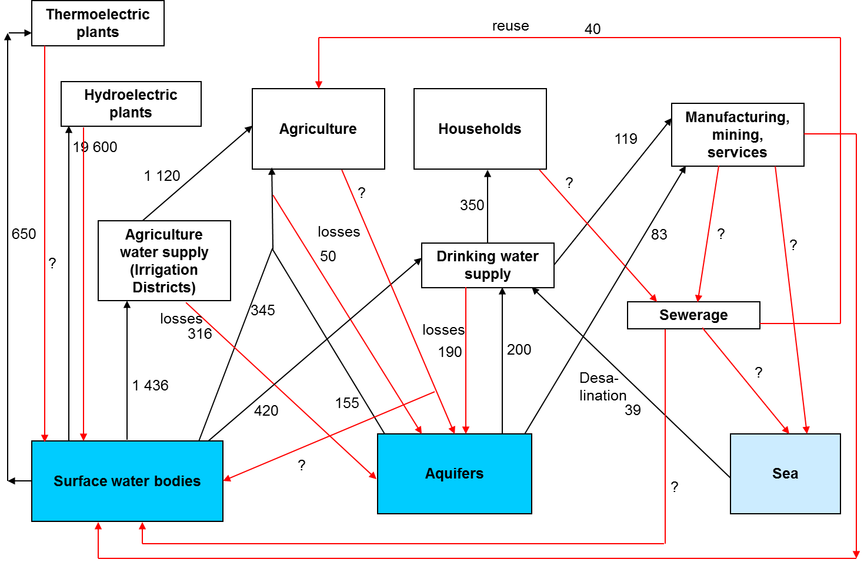
In the second diagram, below, some “flows” of water have been removed in order to simplify the diagram.

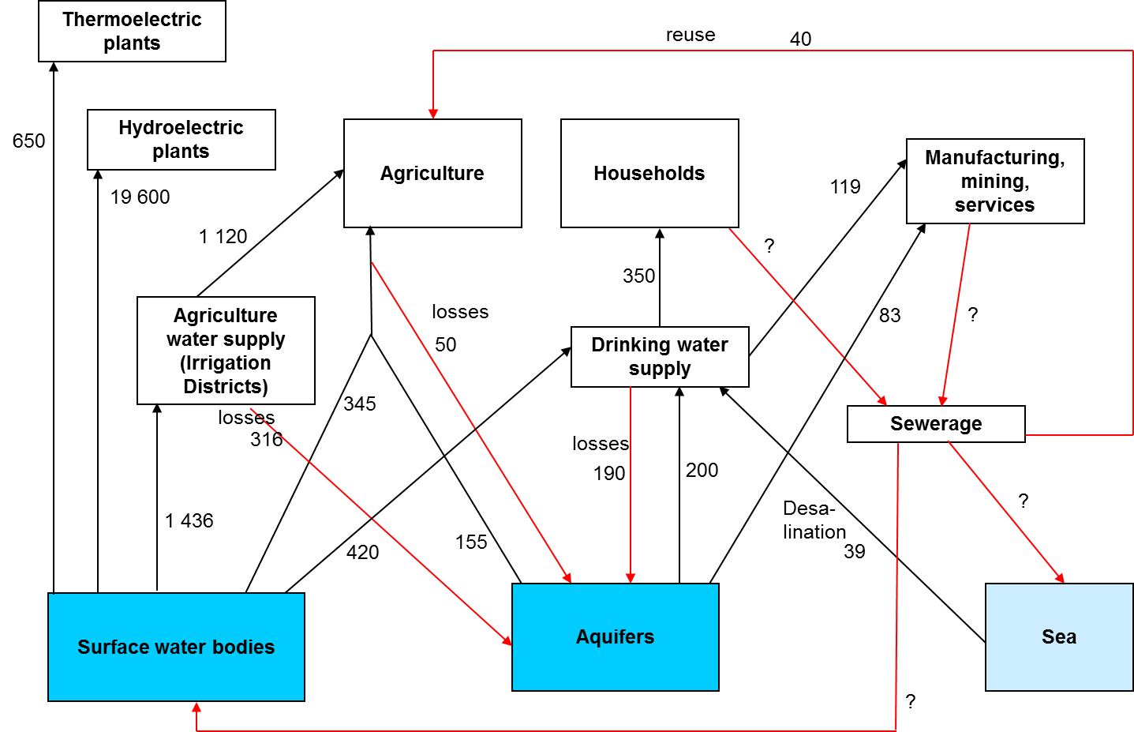

- Can you provide quantitative estimates of the information that is not provided and that is necessary to quantify all the flows of water, such as, water discharged to the sewers and returns to inland water resources? You can use coefficients to estimate the final water use (also known as water consumption).

The following assumptions will be made:

The final water use or “water consumption,” can be estimated using coefficients determined specifically for each case. If the coefficients are not available locally, coefficients from other countries in the region may be used in a first stage, and then adjusted based on data from the country. For the purpose of this exercise, some arbitrary coefficients, based on international data, will be used, as described below

- Hydroelectricity: it will be assumed that all the water turbinated is returned to inland water resources after leaving the power plant.
- Thermoelectricity: it will be assumed that 95% of the water abstracted for cooling is returned to inland water resources. The rest, 5%, is evaporated.
- Households: it will be assumed that 80% of the water received goes to the sewers, the rest is evaporated.
- Agriculture: it will be assumed 40% of the water used (received from the irrigation districts and abstracted by agriculture) is returned to inland water resources.
- It will be assumed that the different industries and services, other than agriculture, discard 70% of the water received.

Regarding the destination of wastewater, some assumptions can be made based on the different discharges identified and/or the general known facts of the country or region. The following assumptions will be made for this exercise:

- The water discarded by industries and services is sent to the sewers, to the sea, and to surface water in equal proportions.
- 40 million cubic meters per year of the water discarded through the sewers is sent to agriculture for reuse (information provided in the statement of the problem). From the amount not sent to reuse half is sent to surface water bodies and half to the sea.
- 80% of the water discarded by agriculture goes to groundwater and 20% to surface water.

With these assumptions, the following estimates are made (all the numbers are in million cubic meters of water per year):

- Returns to surface waters (H.1.1) from hydroelectric plants = 19 600.
- Returns to surface waters (H.1.1) from thermoelectric plants = 618.
- Returns to surface waters (H.1.1) from agriculture = 20% (40%)(1 600) = 515.
- Returns to groundwater (H.1.2) from agriculture = 80% (40%)(1 600) = 129.
- Wastewater from households to sewers (F.3.1) = 80% (350) = 280.
- Wastewater from industries and services to sewers (F.3.1) = 1/3 (70%)(202) = 47
- Returns from industries and services to surface waters (H.1.1) = 1/3(70%)(202) = 47
- Returns from industries and services to the sea (H.2) = 1/3(70%)(202) = 47
- Flows from sewerage to the sea = 50%(287) = 143.5. This will be rounded as 144.
- Flows from sewerage to surface water bodies = 50%(287) = 143.5. This will be rounded as 143.

The following diagram shows the estimated values in red.

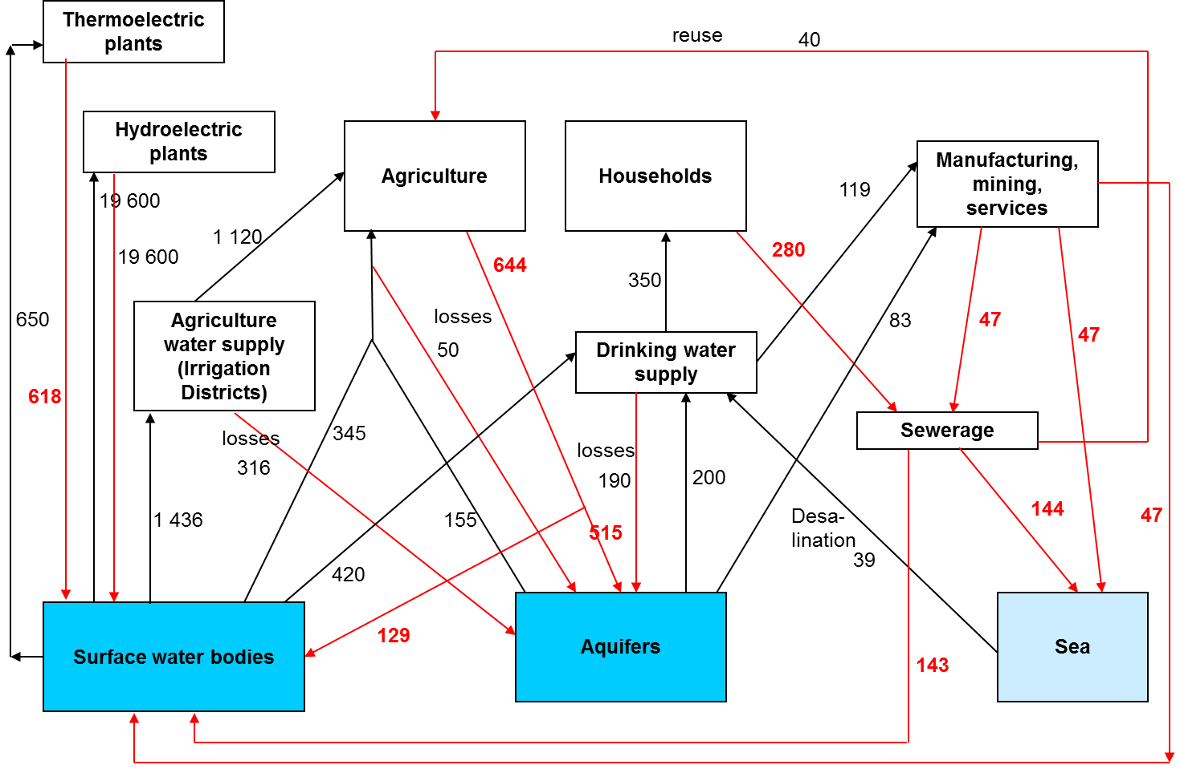

Module II: Basic understanding of the natural water cycle

- Make a diagram that shows all the interconnected flows of water entering and leaving Unu, with the information provided. Use the template provided.

The following diagram shows a simplification of some of the main elements of the water cycle. For simplicity, all the precipitation is assumed to fall on the soil, and from there it becomes surface runoff or infiltrates to the aquifers. It is also assumed that all the evapotranspiration comes from the soil.

In reality the flows are much more complicated. Precipitation infiltrates and later becomes surface water. Surface water can also feed the aquifers during a season or part of a season. All these details can be incorporated in the diagram as more data become available, but it is useful to start with a very simple diagram, such as the one shown below.

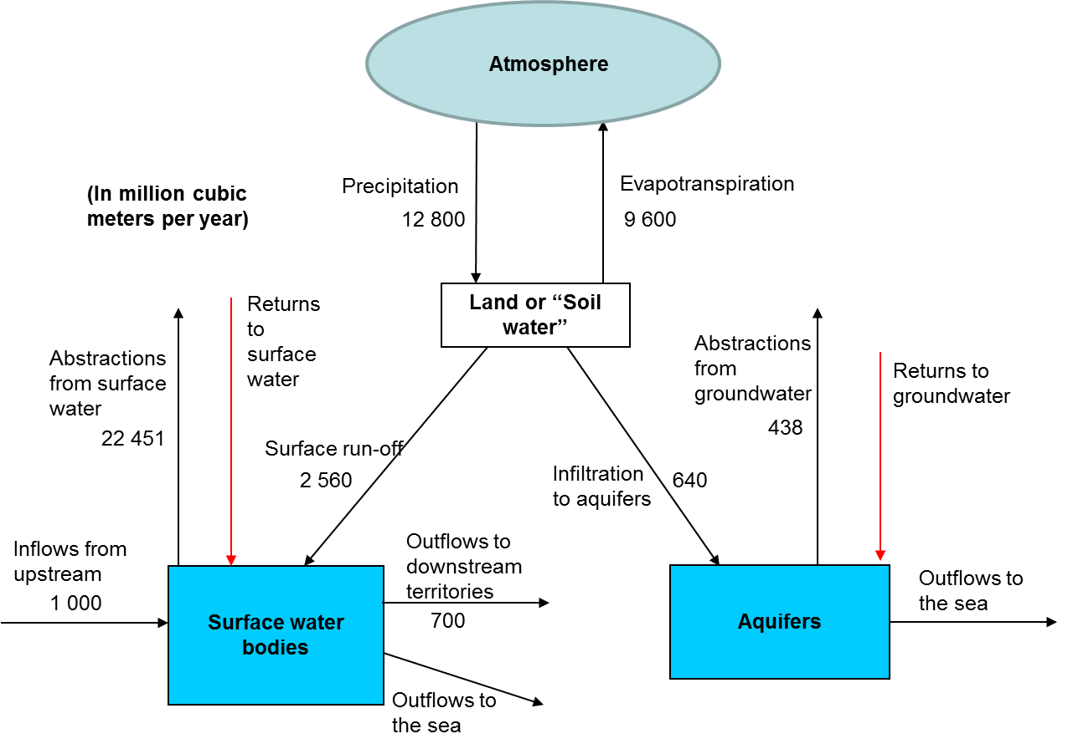

Symbols and Abbreviations

1 hm³ | 1 million cubic meters = 1 gigaliter = 1 GL
1 t  CPC | 1 metric ton = 1000 kg  Central Product Classification (version 2 is used in this example).
GCF | Gross Capital Formation
GFCF | Gross Fixed Capital Formation
IRWS | International Recommendations for Water Statistics
ISIC | International Standard Industrial Classification of All Economic Activities (Revision 4 is used in this example).
RoW | Rest of the World. Used to designate economies to which Unu exports products or from which Unu imports products.
SEEA-CF | System of Environmental-Economic Accounts, Central Framework
SEEA-Water | System of Environmental-Economic Accounts for Water.
SNA 2008 | System of National Accounts, 2008 edition.

Module VI: Physical supply, use, and asset tables

- Construct the supply and use tables using the information provided in module I.

The diagrams constructed in module I can be written in a tabular form. A tabular representation of the diagrams is easier to process in a computer. The diagrams are useful when dealing with a small number of elements, but as the number of elements in the diagrams increases, the tables become a much more efficient way of recording and sharing information.

The physical supply table is shown below:

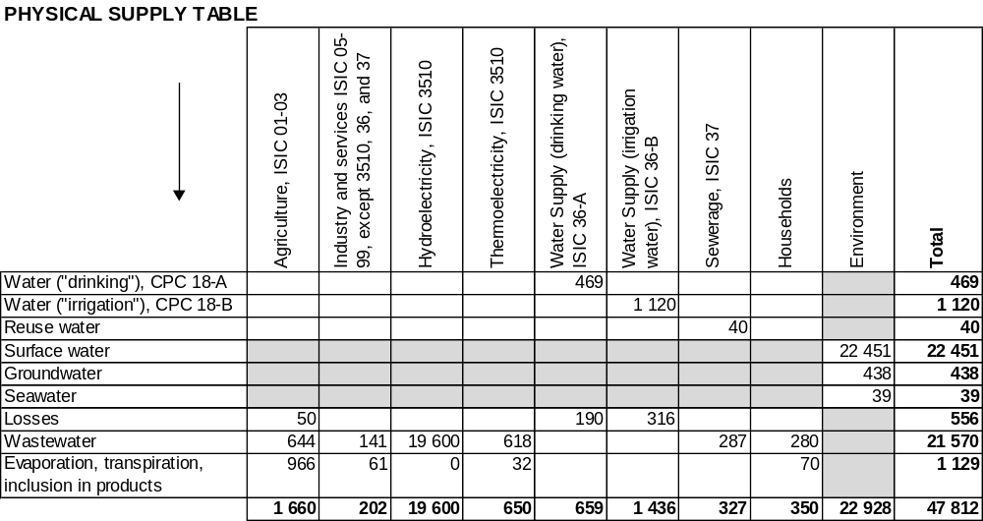

Note that the final row in the above physical supply table “Evaporation, transpiration, inclusion in products” is equivalent to Water Consumption, or Final Water Use.

The physical use table is shown below:

